Yingshi Information Technology (Beijing) Co., Ltd.
Coremail XT V6.0
Webmail Manual



Copyright Statement

The copyright of this document belongs to Coremail®, and all rights are reserved. No part of this document may be made public, reproduced or otherwise distributed to a third party by any company or individual without written permission. Otherwise, it will be held accountable.

Disclaimer

The document only provides periodical information. Its content may be updated at any time according to the actual situation of the product without further notice. The company shall not be liable for any direct or indirect loss caused by improper use of the document.

Document Update

This document was last revised by Coremail® in March 2021.

Company Website
http://www.coremail.cn

Sales hotline | 400-000-1631
Technical support hotline | 400-888-2488

- Revision History

Version | Modification Date | Modified by | Revision Content
V1 | 2020.03.10 | jlxu | Created the document and updated XT6 product specification
V2 | 2020.08.13 | jlxu | Modified format
V3 | 2020.11.13 | jlxu | Modified format, E-mail recall and organizational contacts, added quotation marks for reference documents, and added personal settings entrance
V4 | 2021.03.01 | jlxu | Modified format

- Review History

Version | Review Date | Reviewed by | Review Content
V2 | 2020.11.13 | Sherry、xh | Modified format, E-mail recall and organizational contacts, added quotation marks for reference documents, and added personal settings entry

Contents

1. Webmail Introduction 5

1.1 Login Webmail 5

1.2 Webmail Welcome Page 6

1.2.1 Navigation Bar 8

1.2.2 Shortcut Bar 8

1.2.3 Operation Display Area 8

2. My Mailbox 8

2.1 Compose 9

2.1.1 Send 9

2.1.2 Preview 11

2.1.3 Save Draft 11

2.1.4 Cancel 11

2.1.5 Select Recipient 12

2.1.6 Add a Subject 12

2.1.7 Attach Files 13

2.1.8 Insert Signature 14

2.1.9 Formatting Options 14

2.1.10 Check Spelling 15

2.1.11 Full Screen 15

2.1.12 Save to Sent 16

2.1.13 Set as Urgent 16

2.1.14 Return Receipt 16

2.1.15 Schedule Send 17

2.1.16 Burn After Reading 17

2.1.17 Mail Encryption 18

2.1.18 Mail Recall 18

2.2 Mailbox 19

2.2.1 Important 20

2.2.2 Inbox 20

2.2.3 Snoozed 21

2.2.4 Flagged 21

2.2.5 Labelled 21

2.2.6 Drafts 21

2.2.7 Sent 21

2.2.8 Trash 21

2.2.9 Spam 22

2.2.10 Virus 22

2.2.11 Other Folders 22

2.3 Mail List 23

2.3.1 Select 23

2.3.2 Sort 24

2.3.3 View 24

2.3.4 Delete 25

2.3.5 Move to 25

2.3.6 Mark as 25

2.3.7 More 26

2.3.8 Refresh 27

2.3.9 Go to Page 27

2.4 Read Interface 28

2.4.1 Reply 28

2.4.2 Forward 28

2.4.3 Move to 28

2.4.4 Mark as 28

2.4.5 Delete 29

2.4.6 More Options 29

2.4.7 Contact Card 30

2.4.8 View Attachment 31

2.5 Layout 31

2.6 Mail Conversation 32

3. Meeting and Schedule 33

4. File Center 34

5. Contacts 34

5.1 Organizational Contacts 34

5.2 Personal Contacts 35

5.2.1 Contacts 35

5.2.2 Contact Group 37

5.2.3 Search contact 38

6. Settings 39

6.1 Personal Information 39

6.1.1 Personal Informatio 39

6.1.2 Mailbox Password 40

6.1.3 Signature Settings 40

6.2 Interface Display Settings 41

6.2.1 Mailbox Display 41

6.2.2 Mailbox List Display 42

6.3 Sending and Receiving Settings 43

6.3.1 Composing Settings 43

6.3.2 Replying Settings 43

6.3.3 Reading Settings 43

6.3.4 Auto-forward 43

6.3.5 Vacation Responder 43

6.3.6 Template Settings 44

6.4 Categories 44

6.4.1 Categorize 44

6.4.2 Important Mail Settings 45

6.5 Security Settings 46

6.5.1 Whitelist 46

6.5.2 Blacklist 46

6.5.3 Anti-virus 46

6.5.4 Anti-spam Level 47

6.5.5 Security Lock Settings 47

6.5.6 Anti-spam Notification 48

6.5.7 Secondary Verification Settings 48

6.5.8 Login Device Inquiry 48

6.6 Folders and Labels 48

6.6.1 Folder Management 48

6.6.2 Delete Folder 50

6.6.3 Label Management 51

6.7 Schedule Settings 52

6.8 Advanced 53

6.8.1 Share Mailbox 53

6.8.2 Collect From Settings 54

6.8.3 POP3 Settings 58

6.8.4 Coremail Push 58

6.8.5 Reminder Settings 58

6.8.6 Keyboard Shortcuts 59

7. Application Center 59

7.1 Self-service Inquiry 59

7.1.1 Login Inquiry 60

7.1.2 Sent Inquiry 61

7.1.3 Receiving Inquiry 61

7.1.4 Deletion Inquiry 62

7.1.5 Transfer Station Download Inquiry 62

7.2 Quarantined E-mail 62

8. Help Center 63

Webmail Introduction

Coremail XT 6.0 is Coremail's latest mail system. The XT 6.0-style Webmail interface adopts simple and elegant design and provides a number of humanized intelligent operations.

This document will provide you with guidelines for using the Coremail Mail System through Webmail XT 6.0 style templates, and introduce in detail the various functions of Coremail XT 6.0.

Login Webmail

Input the URL of the email system in the "Address" field of the browser, such as "http://IP/coremail", and press "Enter" to redirect the browser to the login page of the Webmail.

To log in to the system, you need to input the correct user name and password on the homepage, and click "Login" to enter the system and use the functions of Coremail XT 6.0.

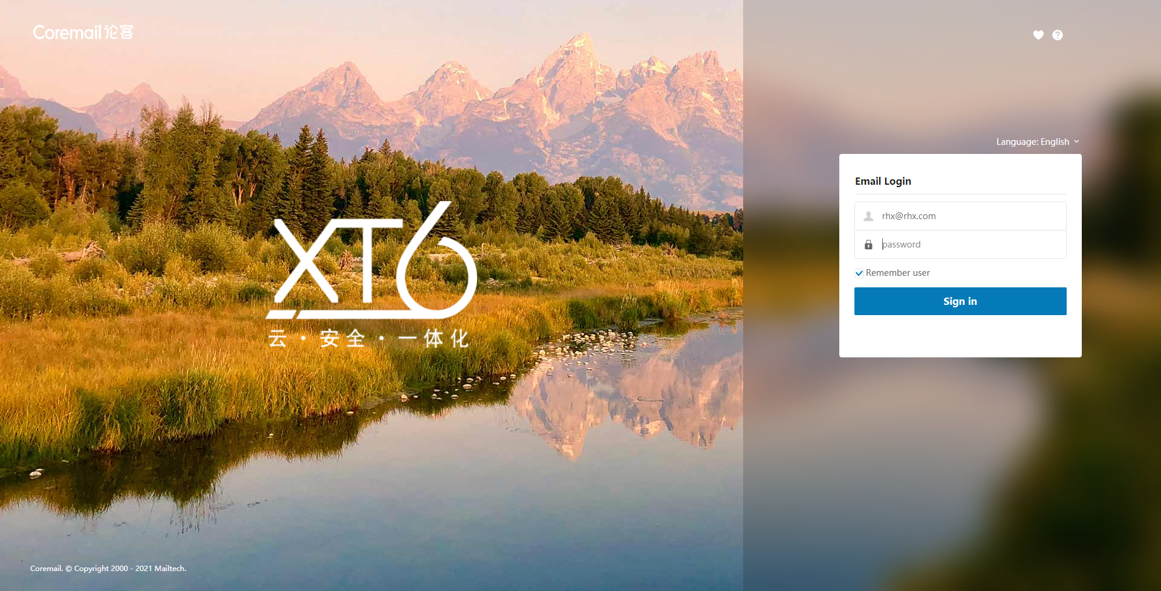

User name/password: If the input user name or password is wrong, the system will give an error message. For example, "User name or password error, or login restricted". After inputting the correct user name and password, the user can log in to the system. If the number of password errors exceeds a certain value, the system will give a captcha, and you need to input the correct password and captcha to log in to the system.

"Remember user name": If you tick this option, the login page will automatically remember the user name of this login to facilitate the next login of user.

Favorite icon: Click this icon to add the Coremail login page to the browser's favorites.

Help icon: Click the icon to enter the Coremail help center.

Webmail Welcome Page

After successful login, the system will display the Webmail welcome page of Coremail system by default. XT 6.0 adds beginner's guide and introduces the new interface functions of XT 6.0.
The interface framework is divided into three parts: "Navigation Bar" on the left, "Shortcut bar" on the top, and "Operation Content Display" below the "Shortcut bar".

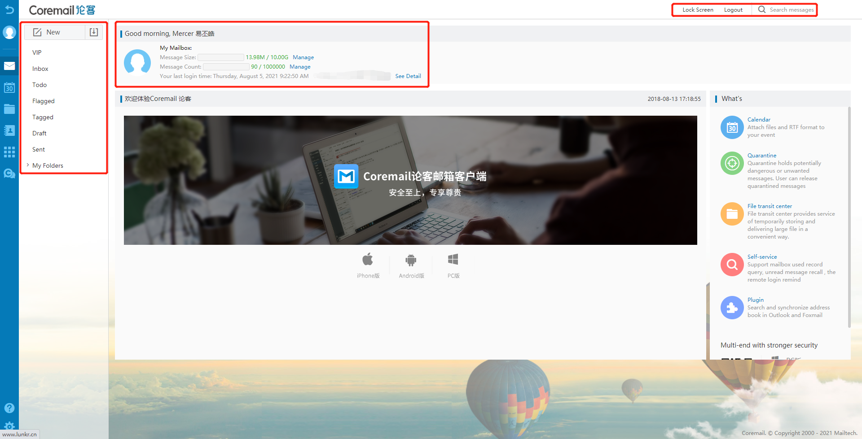

Navigation Bar

At the top of the left navigation bar, the fixed "Compose" and "Check" buttons facilitate the user to quickly compose/receive new E-mails.

When you click the function item in the navigation bar, the clicked function item will change the color to make you clear about the function item content currently browsed, and display the operation content page on the right. The navigation bar includes the following contents: My Mailbox, My Calendar, File Center, Contacts, Application Center, Help Center and Settings.

Shortcut Bar

Lock Screen: After locking screen, the mailbox remains online, but you need to input the correct mailbox password to operate it again.

Logout: The user can easily log out the current user by clicking the "Logout" button. If the user is using a public computer to log in Webmail, be sure to log out before leaving, to avoid later users logging in and using the mailbox through the information left by the user.

Search: Carry out quick full-text search and advanced search according to the keywords of E-mails.

Operation Display Area

The page content in this area will change with the function operation of the navigation bar. The mailbox displays the welcome page by default when logging in, and you can change it in the "Settings - General Settings". The welcome page provides the following information:

(1) Display the current "Unread Mail" information and "Manage" entrance. You can click "Manage" to enter the folder management interface, in which you can create folder and import E-mails to the folder, as well as understand the details of all folders and manage them.

(2) Display the last login location/time/IP address. You can click "Details" to enter the self-inquiry interface to inquire login, sending, receiving, deletion, and transfer station downloads.

(3) Display the city where the mailbox is logged in and its weather conditions.

My Mailbox

Coremail XT 6.0 provides multiple system mailboxes for different usage scenarios.

Compose

Coremail XT 6.0's "Compose" page provides various detailed functions, and you can use the multimedia graphic editing function, attach files, insert signature, send individually, schedule send and other functions according to your needs. At the same time, the system also provides auto draft saving, send attachment reminder and other intimate functions. 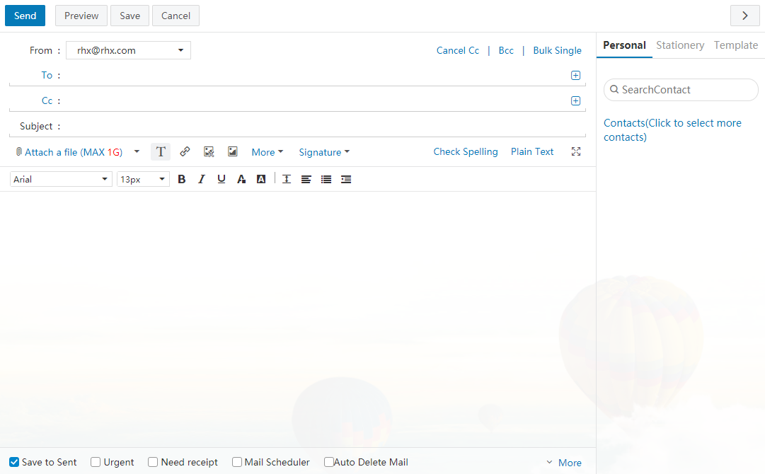

Send

Click "Send" to send the edited E-mail and the sending details will be displayed to the user. Successful sending will display as shown in the following figure:
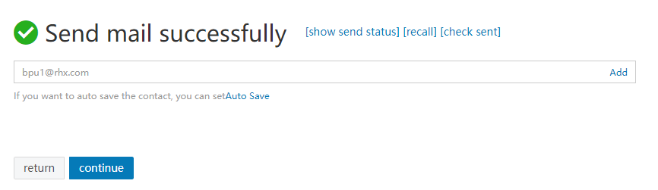

If a recipient is not included in the personal contacts, the user can choose to "Add Contact" or allow the system to automatically save the recipient as a contact. To cancel auto save, click "Do not Auto Save".

When clicking "Send", the system has a check mechanism for recipients, subjects, and attachments:

Recipient format reminder: If the recipient address is empty, the system will prompt "Please fill in the recipient address".

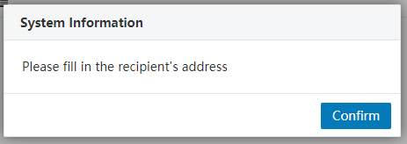

Recipient format reminder: If the recipient address format is wrong, the system will prompt "Please fill in the correct recipient address".

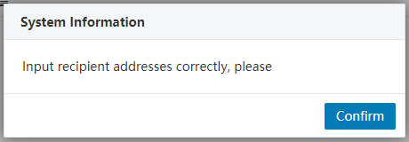

Subject format reminder: If the "Subject" is empty, the system will prompt "Are you sure to send the message without a subject?"

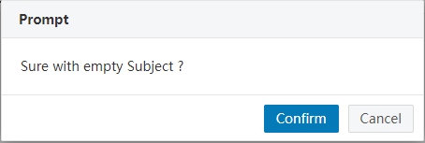
Attachment reminder: If email content contains the word "Attachment" but no attachment is added when sending, the system will prompt "You mentioned attachment in your email but have not attached files, do you want to continue sending?" As shown in the figure below.

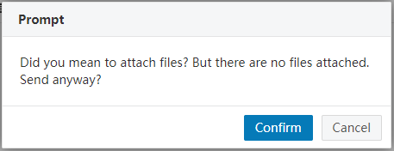

Preview

Click "Preview" in "Compose" page to open a letter preview page in a new window. The display effect of the preview page is same as the display effect of the recipient.

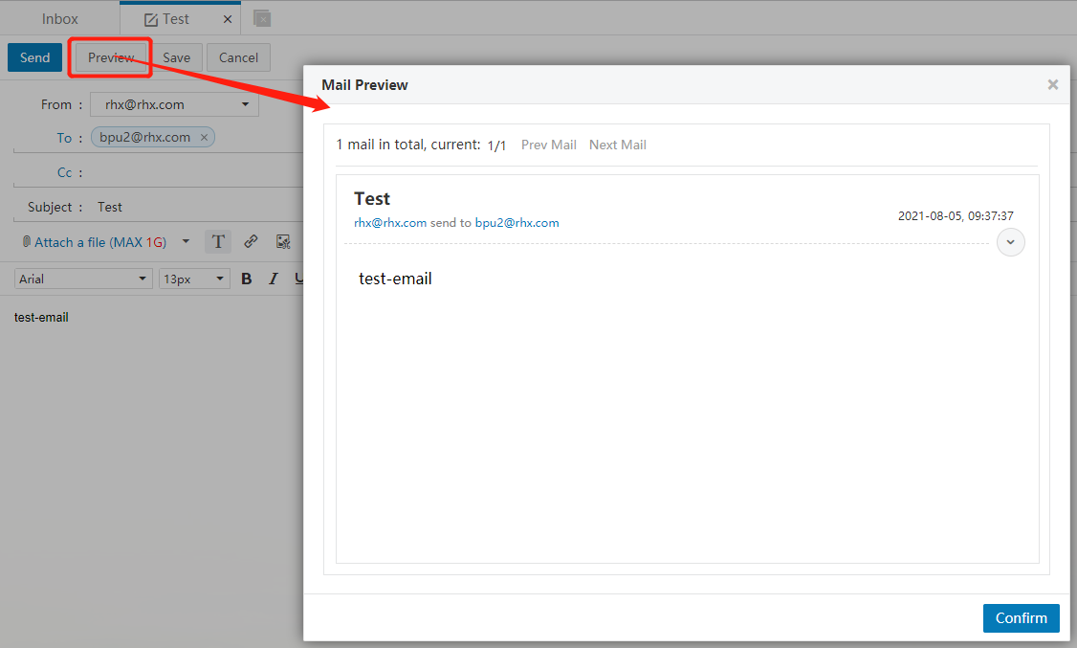

Save Draft
Click "Save Draft" in "Compose" page to save the edited email to "Drafts" for further composing. During the composing process, the system will automatically save draft for the user, to avoid the loss of the unfinished letter due to other unexpected circumstances.

Cancel

When clicking "Cancel" in "Compose" page, if the current email has not saved the draft, the system will prompt "You are writing a email. Are you sure to exit this page?", and give the following options: "Exit and Save Draft", "Exit" and "Cancel". If the current email has saved a draft, clicking "Cancel" will directly exit the current page.

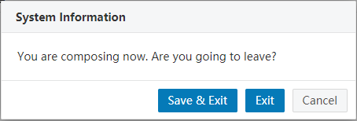

Select Recipient
Coremail provides standard ways to send E-mails, including To, Cc, Bcc, and Send Individually. The main differences are:

Normal sending (To): The E-mail will be sent to the recipient directly;

Add Cc: Send a copy of the E-mail to the recipient whose name is visible to other recipients;

Add Bcc: Send a facsimile copy of the E-mail to the recipient whose name is visible to other recipients. Click "Show Bcc" to add Bcc field below the Cc field.

Send individually: Click "Send Individually" and the corresponding input box will be displayed; add multiple recipients in the input box, and every recipient will only see its own name in the E-mail.

You can input the recipients' E-mail addresses directly in the input box, or select from the personal contacts on the right side, or click the "Recipient" word link or the "+" icon on the right of the input box to select the contacts from the personal and organizational contacts.

Auto match: When inputting the recipient's E-mail address, the system will automatically list all matched users in the personal and organizational contacts, and you just need to select the contacts in the prompt box by using the mouse or the up/down arrow keys.

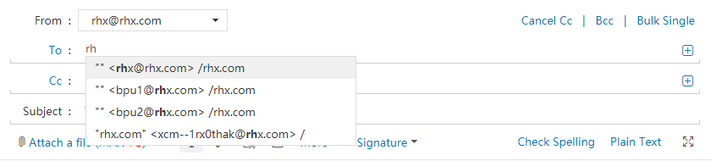
Add sending address from contacts: When the user clicks the "Recipient/Cc/Bcc" or the "+" icon on the right side of the address field, the system will pop up a list of contacts' addresses, and the user can directly select contacts from the personal contacts and organizational contacts. After selecting group/department from the tree directory on the left, the contacts in the corresponding group/department are listed in the middle contact display area; add the selected contacts to the sending contact field on the right, and then click "OK".

Add Subject
Fill in the subject of the current E-mail. If the E-mail is sent without filling in the subject, the system will automatically fill in the subject as the name of the first attachment.

Add Attachment
If the user needs to send a file in the format of *.doc, *.txt, *.zip, *.html, etc. when sending an E-mail, then the attachment function is required. Note: The attachment size and network speed will affect the upload time. Therefore, it is recommended to compress large files before uploading them.
- Click "Attach Files" to upload attachments of specified size (configured by the management background) locally.
- Click the drop-down button next to "Attach Files" to pop up the following options: "Add from file center", "Upload to file transfer station", "Voice attachment" and "Video attachment".

Add from file center: Click the option to pop up a box, which contains four label buttons: document transfer station, personal network disk, enterprise network disk, and attachment. Select the files to be attached and click "OK" to add the attachment of specified size (configured by the management background);

Upload to file transfer station: Upload the local file to the file transfer station, and the uploaded file is added as attachment;

Voice attachment (support IE browser only): Select a recording device to record the voice as an attachment to upload;

Video attachment (support IE browser only): Select a recording device to record the video as an attachment to upload;

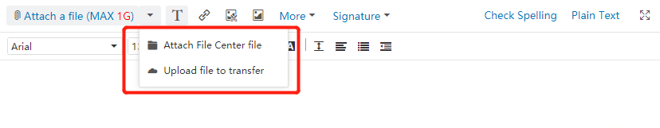
- HTML5 attachment drag function supports IE10, IE11, Chrome, Firefox and other browsers. You can drag and drop the file directly to the "Compose" window and the system will automatically open the "Attach Files" area.

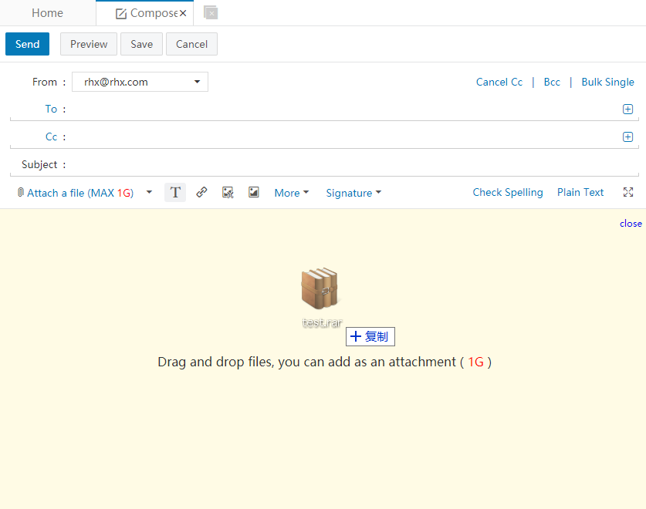
- Download Attachment: Click "Download" button after the attachment directory to download the attachment locally.
- Preview Attachment: Click "Preview" button after the attachment directory to directly preview the attachment.
- Delete Attachment: Click "Delete" button after the attachment directory to delete the attachment.

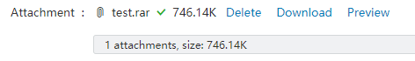

Insert Signature

For the body of the email, the user can choose to add different signatures. Click the "Signature" button in the "Compose" page to display the menu options, and the user can select "Not use" or use a set signature, or click "Edit Signature" to enter the signature setting page. For detailed operation of signature, please refer to the relevant introduction in Section 6.1.3 "Signature Settings" of Chapter 6.

Formatting Options

The system provides plain text/multimedia text editing formats. When editing the email, the default format is plain text. You can click "Multimedia Text" to switch to multimedia text editing method, and click "Plain Text" again to return to plain text editing method.
When switching from multimedia text to plain text, the system will pop up a prompt, as shown in the following figure. Click "OK" to enter the plain text editing page. You can set the default editing format in "Settings - Sending and Receiving Settings - Composing Settings".
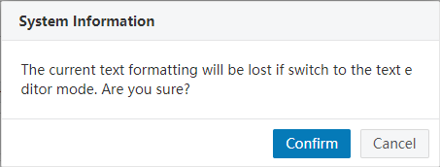

Check Spelling

In multimedia text mode, you can click the "Check Spelling" at the top right of the "Compose" interface to discover the spelling errors in English and Chinese and mark them.

Full Screen

When editing an E-mail, the user can click the "" button at the top right of the "Compose" interface to enter full screen mode and click "" button to return to the normal screen mode.

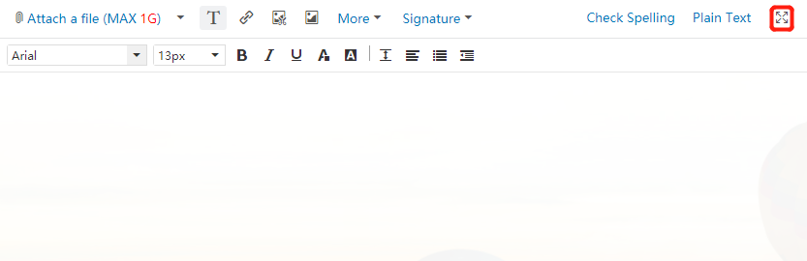

Save to Sent

There is a row of function options below the "Compose" box. If selecting "Save to 'Sent'", you can save a copy of the current email to the [Sent] folder after it is sent, and you can find the sent email in this folder.

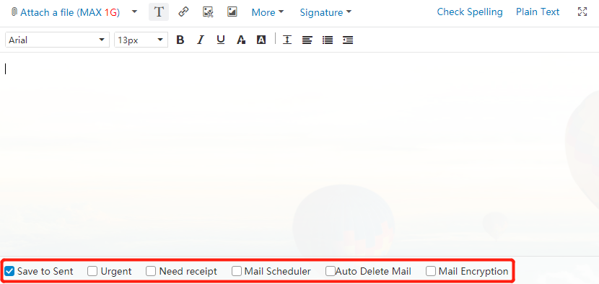

Set as Urgent

Tick "Set as 'Urgent'" to increase the priority of the email and the recipient will see a red exclamation mark before the subject when it arrives.

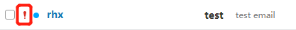

Return Receipt

Select the "Return Receipt" in the function options below the "Compose" box. When the recipient receives the email and reads it, the system will return a "Read receipt" to the sender.

After the recipient receives the email, the top of the page will prompt "The sender has requested a return receipt. Do you want to send the receipt?"

If the sender sends the receipt, the sender will receive a return E-email with "Read" in the subject:

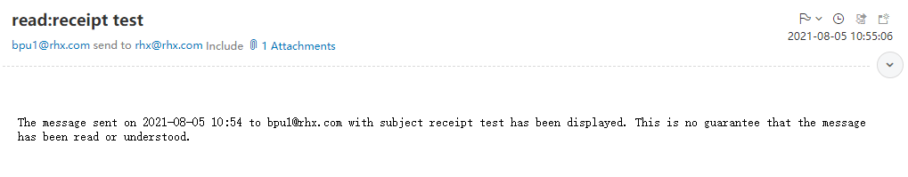

Schedule Send

When composing the email draft, the user can also set the "Schedule Send" function to send the email at a scheduled time. The time must be a time later than the current time, and then click "Schedule Send". The system also supports to set the time zone of the recipient. As shown in the following figure:

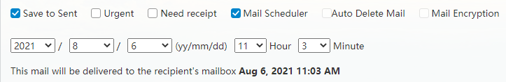

If the "Schedule send date" is incorrect, the system will return "Failed to send the email". The emails that set the schedule send will be saved in drafts and marked with different labels in the drafts. If the user needs to re-view, set or send, or cancel the scheduled email, just set it in the drafts.

Burn After Reading

After ticking "Burn After Reading", you can set the reading times and destruction time of the email. When the email reading times exceed the limit number of times or the email destruction time has reached, the email content will be destroyed and cannot be read.

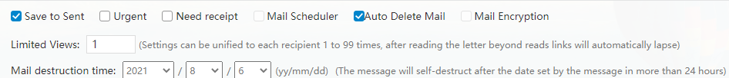

Email Encryption
Coremail provides mail encryption and decryption center using an exclusive algorithm. When sending important or confidential mails, you can add a separate password to the mail, and the recipient needs to unlock the password to read the mail body and attachments. Even if hackers track the recipient's email, they can't directly read the content of the mail, thus ensuring the security of the information.

When composing mail, click the "Mail Encryption" at the bottom.

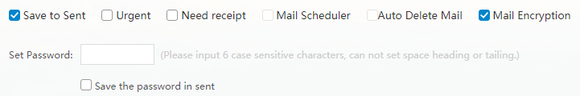

When a recipient receives a mail in Webmail, he or she can view the mail by entering the same password as the sender.

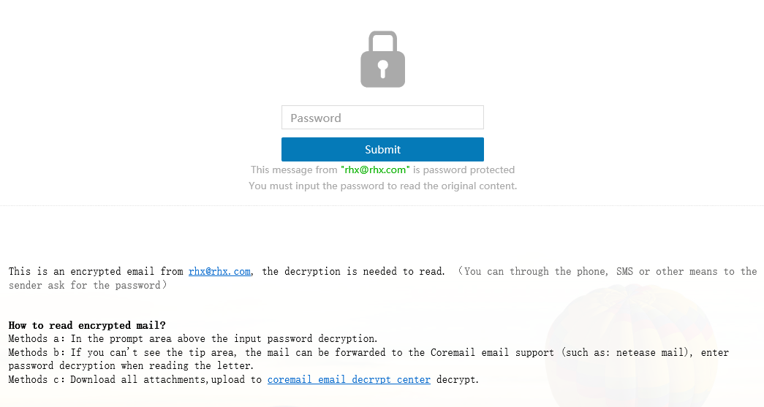

Mail Recall
If you find that a mail is written or sent incorrectly after sending it in Webmail, you can recall the mail in the [Sent] folder.

[Note]: If the recipient has already read the mail, it can't be recalled!

Open the mail that needs to be recalled in "Sent", click "Recall Mail" in the menu bar, and the system will pop up a prompt message:

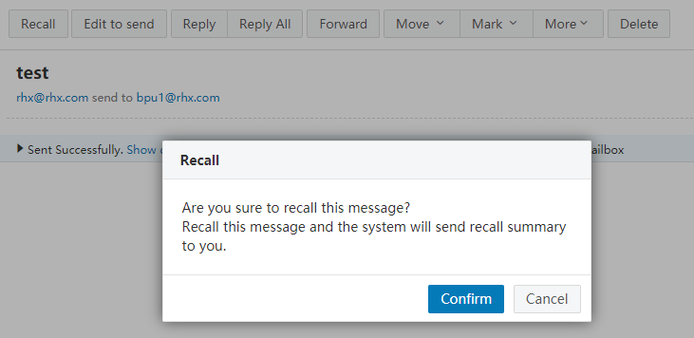

You can also click "Recall Mail" for unread mails in "Self-help Inquiry - Sent Inquiry". After click "OK", the system will pop up a reminder bar of recall status and notify the user with a system notification.

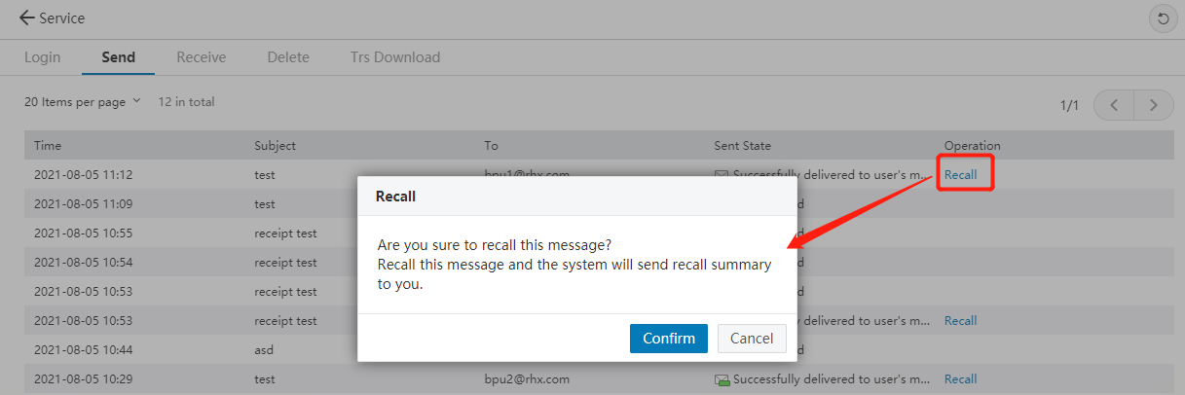

Mailbox
The user clicks the mailbox and is greeted with the navigation bar on the left side. We will go through each folder one by one: Important, Inbox, Snoozed, Flagged, Labelled, Drafts, Sent, Trash, Spam, and Virus folders.

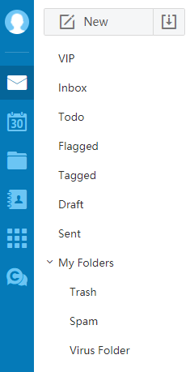

Important
The [Important] folder can filter your mails and allow you to quickly browse mails from important contacts and with important subjects. You can quickly click on the yellow star mark on a mail to quickly mark it as important.

Inbox
The [Inbox] folder stores the mail you receive, lists the total number of mails contained and the number of new mails, and displays various attributes of the mails, such as the sender's address, subject, with/without attachment, and sending time. You can sort, move, mark, view, delete and snooze the mails in the inbox.

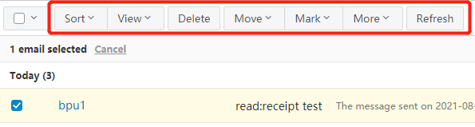

- After selecting mails in the [Inbox], you can perform the following operations:
Sort the mails according to different latitudes, including: ascending/descending by time, ascending/descending by sender, ascending/descending by subject, and ascending/descending by attachment size;
- View mails (all, unread, read, marked, other marks, unmarked, labelled, unlabeled, urgency, normal, tardy, with attachment, without attachment, replied, forwarded);
- Delete mails;
- Move mails to (other folders), mark the mails as (read, unread, flagged, other marks, important, priority, top or snooze);
- More operations include reply (replay, reply all), forward (forward direct forward, forward as attachment), report, block, categorize, re-edit, delete permanently, and download all, etc.
- Refresh the mail list.

Snoozed

Coremail XT6.0 provides "Snooze Mail" function for users to mark the task mails to be completed as "Snoozed" and manage the tasks by time.

Flagged
The user can flag the mails with different colors. All flagged mails in the mail list are displayed in the [Flagged] folder.

Labelled
The "Label" function meets the requirements of users to quickly classify mails, and users can customize the label of mails. All labelled mails in the mail list are displayed in the [Labelled] folder.

Drafts
The [Drafts] folder stores uncompleted or intentionally saved mails. It can play the role of temporary storage to store some mails that do not need to be sent immediately for later use or sending. If you click "Save Draft" or set "Schedule Send" in "Compose" page, the mails will be stored in the [Drafts] folder. You can click "Subject" in [Drafts] to re-enter the "Compose" page, re-edit or send the mail.

Sent

The [Sent] folder stores the successfully sent mails. You can click "Subject" in [Sent] to read the mail.

Trash
The [Trash] folder stores other mails deleted from other folders. The system will clean the [Trash] folder regularly, so do not put the required mails in the [Trash] folder. Deleting or cleaning mails in [Trash] will permanently delete the mails, which cannot be restored.

Spam
Coremail provides an intelligent anti-spam system. When the system judges some mails as suspicious spam, they will be delivered to the [Spam] folder. For the processing of these suspicious spam, the user can set and understand through "Settings - Security Settings - Anti-spam Level".

Mails judged as spam by the system will be delivered to the [Spam] folder, and the user can timely and clearly know the receiving condition of spam. At the same time, the system will automatically clean up the spam in the [Spam] folder regularly.

Virus
Coremail provides anti-spam function. When the system judges some mails as virus mails, they will be delivered to the [Virus] folder. For the processing of these virus mails, the user can set and understand through "Settings - Security Settings - Anti-virus".

Other Folders

Quick new folder

You can click after the "Other Folders" to add a folder. You can also create a new folder through "Settings - Folder and Label - Folder Management". For details, see Section 6.6.

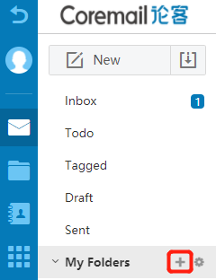

Quick access to folder management

The navigation bar provides the mailbox folders frequently used by the user. You can also enter the "Folder Management" interface through the settings icon behind "Other Folders", as shown in the figure below. In this page, you can learn about each mailbox folder and manage it (clean, delete, rename, and sort folders). You can also manage the folders through "Settings - Folder and Label - Folder Management". For details, see Section xxx.

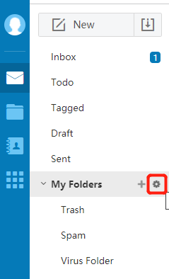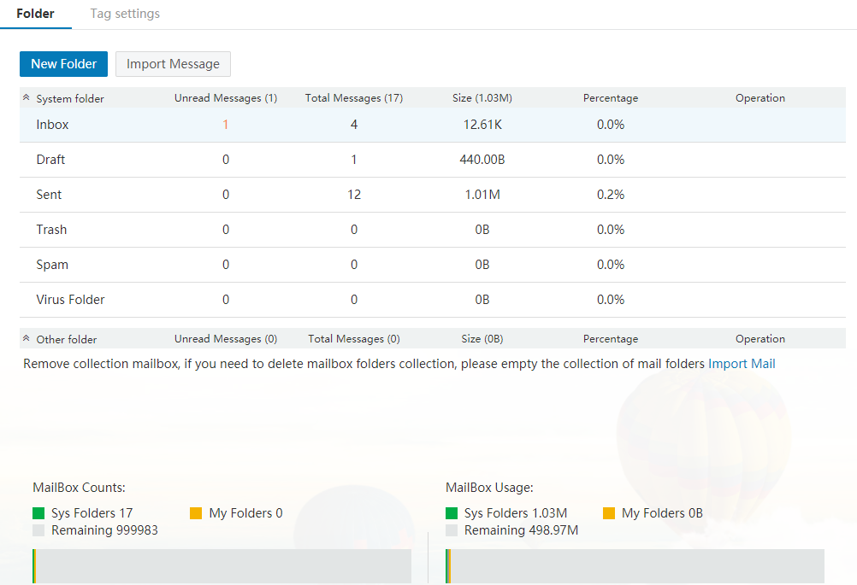

Mail List

Select

You can select mails in the mail list according to different options.

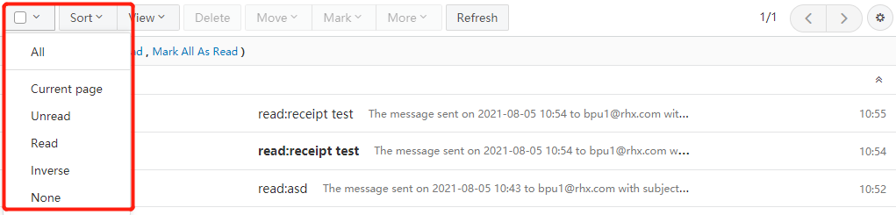

All: All mails on other pages can be selected in batch.

Current Page: All mails on the current page can be selected.

Read: All read mails on the current page can be selected.

Unread: All unread mails on the current page can be selected.

Invert Selection: Invert selection of all unselected mails on the current page.

Deselect: Deselect all the mails checked on the current page.

Sort

You can choose to sort the current mail list display order according to different sorting rules.

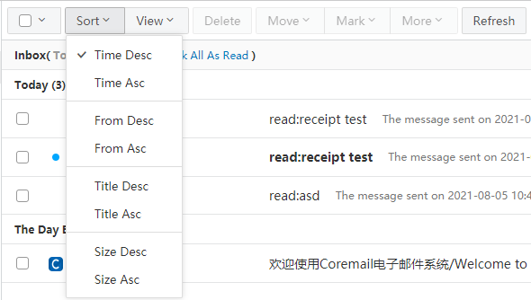

View

Coremail provides various rules for viewing the mail list. You can select the rules as needed to list the unread, read, labelled, flagged, urgency, normal and tardy mails, or view mails with/without attachment, replied and forwarded.

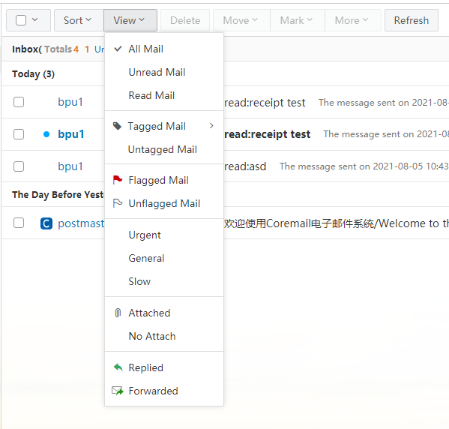

Delete

You can select one or more mails in the mail list and click "Delete" to move the mails to the [Trash] folder.

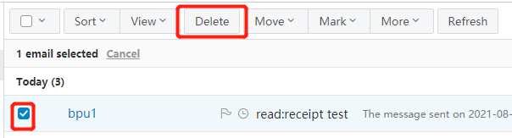

Move to
You can select one or more mails in the mail list, click "Move to" and select other folders from the drop-down list to move the selected mails to the selected folder.

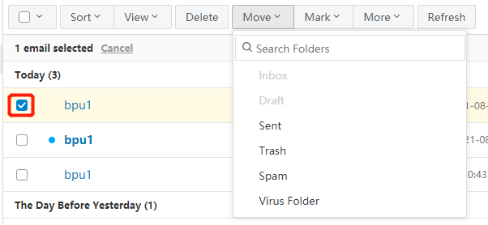

Mark as
You can select one or more mails in the mail list and click "Mark as" to mark the mails differently.

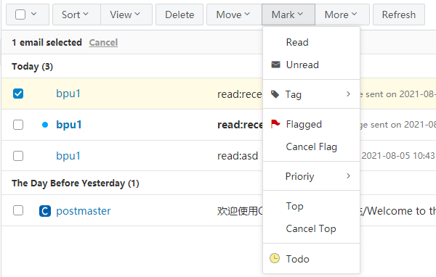

Mark reading status: Mark the mail as read or unread.

Mark as label: Specify more than one custom labels for the mail. The system provides 9 labels by default, to facilitate the user to classify and sort the mails.

Mark flag: Mark a red flag on the mail, which is displayed in the mail list to facilitate the user to identify.

Other marks: Provide 8 colors of flags, which is displayed in the mail list to facilitate the user to identify.

Mark as important: Mark the mail as important (yellow star), and the mail will be added to the [Important] folder.

Mark priority: Mark the mail status as urgency or tardy.

Mark on top: Keep the mail at the top of the mail list.

Mark as snoozed: Mark the mail as snoozed and set the processing time.

More
In addition to the above basic operations to the mail list, the system provides more operation options. You can select one or more mails and click "More" to see the following operation options. The specific functions corresponding to each option can be referred to Section 2.4.

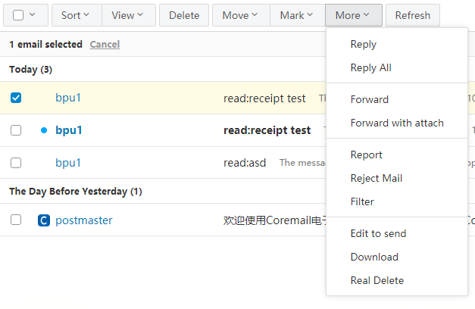

Refresh

After the mail is marked as snoozed, completed, important, cancelled important, deleted, etc., the page only refreshes the current page and the page position remains at the position before the operation.

Go to Page

Click the page number in the top right corner or at the bottom of the mail list to quickly jump to any page number.

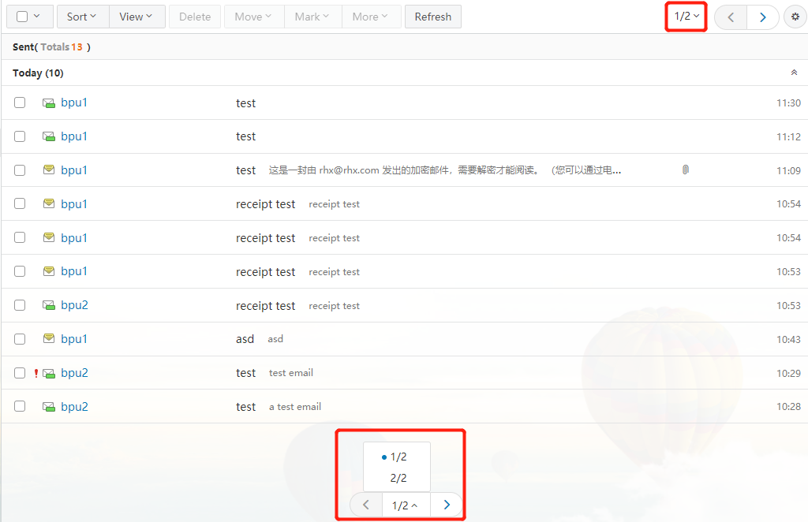

Read Interface

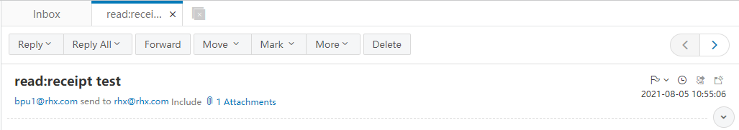

Reply
Reply: Select "Reply" in the toolbar to go to the "Reply" page. The system will reply only to the sender of the original mail and automatically add the recipient and subject.

Reply All: Select "Reply All" to go to the "Reply" page. The system will reply to the sender, all recipient and Ccs of the original mail and automatically add the recipient and subject.

Reply with Attachment: If the original mail has attachments, the reply will also include the attachments.

Forward
Forward the mail to other users. You can click "Forward" to go to the "Forward" page, and the system will automatically add the subject. If the mail has attachments, they will also be included in the forwarded mail.

Move to
Select other folders in the box to mode the current mail to the selected folder.

Mark as
Mark the current mail differently. For details, refer to the marks in the mail list: Read, Unread, Custom Label, Flag, Other Color Flag, Important, Priority, Top and Snoozed.

Delete
Delete a mail from the inbox. You can click "Delete" to move the mail to the [Trash] folder, and the page will display the next mail.

More Options

Permanently Delete

Delete the mail from the system rather than move to the [Trash] folder. This operation cannot be undone.

Re-edit

Re-edit the current mail and send it again. You can click "Re-edit" to enter the compose page, which will display the original mail format, keep the original recipients but modify the send to the current user.

Forward with Attachments

Forward the attachments as attachments.

Initiate Meeting

Automatically transfer the relevant person and content of the mail to a meeting.

Add All to Personal Contacts

Add the recipients, Ccs and senders of a mail to the personal contacts.

Download Mail

Save the current mail to the local computer in.eml format.

Print Mail

Enter the print preview page.

Report

Report the current mail as "Spam", "Illegal" or "Other" and select whether to add the sender to the blacklist.

Block

Click "Block" to add the current sender to the blacklist, and no subsequent mail from the sender will be received.

Categorize

Select to move all mails about the sender to the designated folder.

View Header

Display the header details of the mail in the mail content display box.

View Original Text

Display the original mail details in a new window.

Code

GBK: Display the mail content in the display box in simplified Chinese code.

UTF-8: Display the mail content in the display box in Chinese or other language code.

Big5: Display the mail content in the display box in traditional Chinese code.

Remark

Remark the mail (50 words).

Contact Card
Hover the mouse over the contact (sender/cc/recipient) of the current mail to display the contact card.

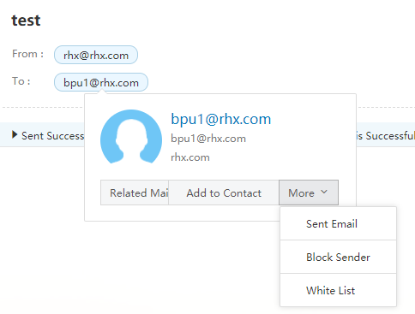

View correspondence with this contact

Click "Correspondence" to view all mail correspondence with the contact.

Add the contact to the personal contacts

Click "Add to Personal Contacts" to add the contact to the personal contacts. After successful adding, the system will display a prompt at the top of the mail, and the "Add to Personal Contacts" in the contact card will change to "Edit Contact". You can click "Edit Contact" to directly enter the contact editing page.

More

The "More" option in the contact card provides "Compose", "Block", "Add Whitelist" and other entrances.

View Attachment

When you receiving a mail with attachment, there will be an attachment prompt at the top of the email, as shown in the figure below.

Click "View Attachment" button at the top of the mail or directly check the bottom of the mail body to view the attachment list.

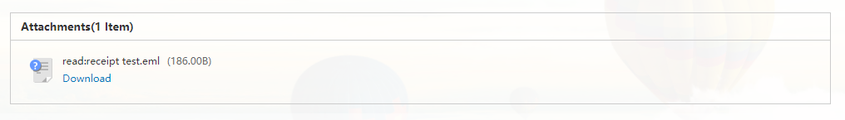

Preview: Click "Preview" to view the attachment online.

Download: Click "Download" to download the attachment locally.

Save to Personal Netdisk: The user can directly save the attachment to the personal netdisk of mailbox.

Layout
The admin can click the  button on the right side of the inbox to select the mail list layout in the reading pane. As shown in the figure below.

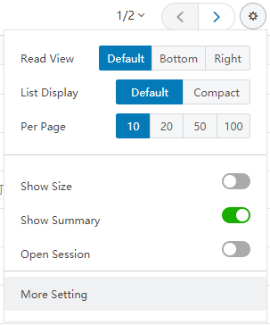

Reading pane

Default: The default layout of the system is a list and the mail content needs to be clicked to read.

Bottom: The upper part of the receiving page displays the mail list, and the lower half displays the content of the selected mail.

Right: The left side of the receiving page displays the mail list, and the right side displays the content of the selected mail.

List display: Default to normal. If selecting "Compact", the row height will become compact.

Show mails per page: Default to 20, and 10, 50, and 100 are optional.

Mail size: Select whether to display mail size.

Body abstract: Select whether to display the body abstract.

Conversation View: Select whether to enable conversation view mode.

More settings: Go to "Personal Settings - Mail List Display" page.

Mail Conversation

"Mail Conversation" can aggregate multiple correspondences generated by the same subject, eliminating the need to search for correspondence records of the same subject everywhere. If you select the "Mail Conversation" mode, the mails of the same subject in the list are displayed as the following figure, and the number on the right of the list shows how many mails are contained in the current conversation.

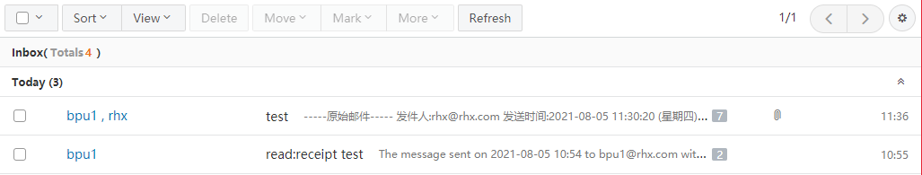

The conversation mode is off by default. You can click the button in the upper right corner of the inbox to quickly turn on or off the conversation mode.

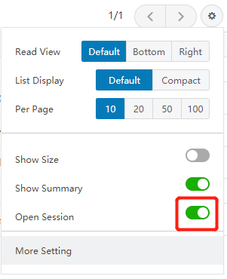

In the "Settings Center - Interface Display Settings - Mail List Display", you can also set to enable the "Mail Conversation" mode.

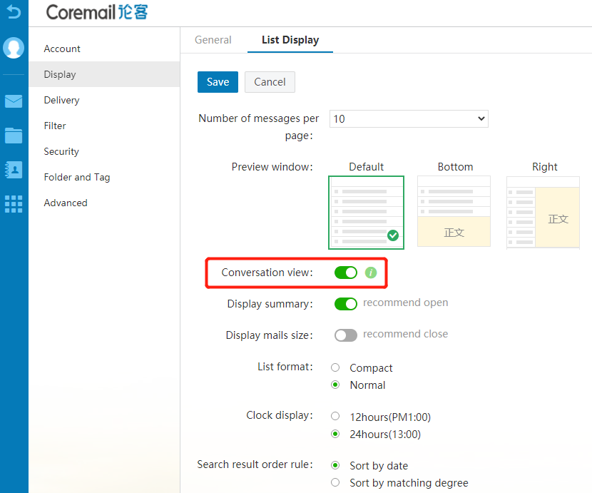

Meeting and Schedule
"Meeting and Schedule" can help you to arrange your work and life time clearly and reasonably, and you can synchronize your meeting schedules, office events, customer meetings and other schedules on your mobile phones, tablets, laptops and other terminal devices.

For details, please refer to "Coremail XT V6.0 Meeting and Schedule Manual".

File Center

The "File Center" includes enterprise netdisk, personal netdisk, file transfer station, and attachments.

For details, please refer to "Coremail XT V6.0 File Center Manual".

Contacts

Organizational Contacts
Coremail's organizational contacts displays the E-mail addresses of all users within the same organization (enterprise) in the form of an organizational structure. The user does not need to add the contacts to personal contacts and can view the contact information of all colleagues. The operation of organizational contacts is simple and its application is flexible:

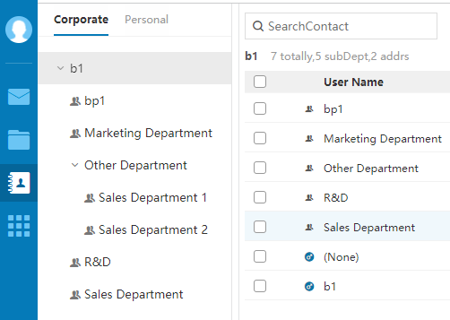

Tree structure: Provide tree structure display mode to display the "Organization - Departments - Sub-departments - Contacts" clearly.

Account confidential: The admin can set some accounts as confidential to hide their information in the Webmail's organizational contacts.

Flexible sorting: Sort enterprises, departments and users, to better meet the actual conditions of the organization.

Auto match when composing: When inputting Chinese or English for contact in "Compose" page, the system will automatically match the contact in the organizational contacts.

Link contact: The user cannot only select a recipient from the organizational contacts, but also link the contacts with the personal contacts to enrich the contact information.

Personal Contacts

Contacts
Click the  button on the right side of the page to enter the contacts page (organizational/personal). As shown in the following figure:
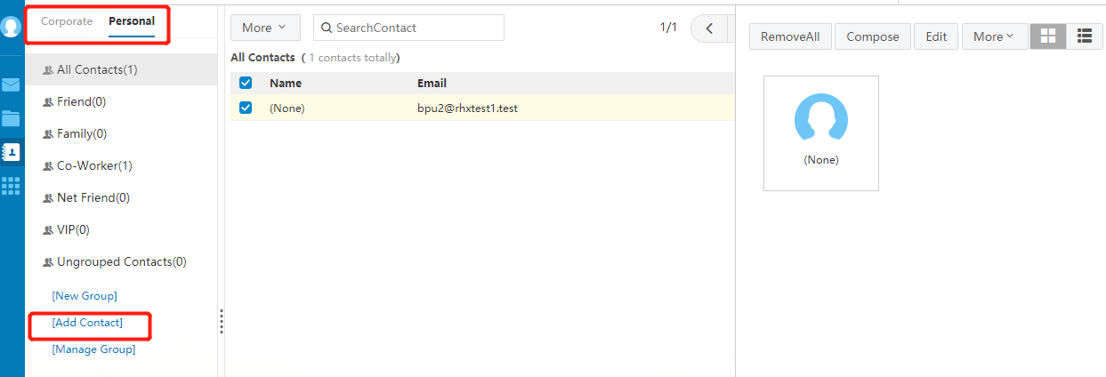

View Personal Contacts: Select to display by contact group, or search by contact name or E-mail address in the "Search contact" field at the top left.

New Contact: Click the "New Contact" button on the left panel or click the "New Contact" option in more options at the top of the list, fill in the contact name and E-mail address, and select the group to add it to. You can also record the contact birthday, mobile phone, instant messaging ID, homepage address, home address, zip code and telephone number, company name, address, zip code, telephone number and fax number.

Operations in personal contacts: The "Personal Contacts" displays the information displayed in personal address list, including the name, E-mail address and mobile phone displayed in list.

You can perform the following operations for the list information:

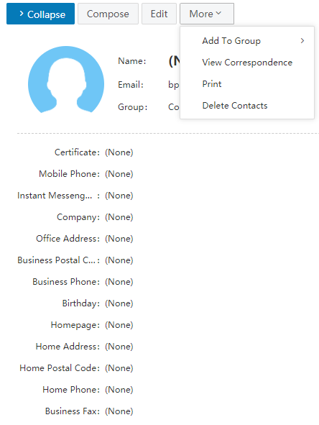

(1) View contact details

For the record of a specific contact, click the contact name or phone number to enter the contact's details page.

(2) Compose to the contact

Select a contact from the list and click "Compose" to enter the compose page, and the system will automatically add the E-mail address to the recipient's address field.

(3) Add to group

After selecting one or more contacts, click the drop-down list of "More", and select add to the desired group to copy the contacts to the designated contact group. After copying, the contact will still appear in this group.

(4) Move to group

After selecting one or more contacts, click the drop-down list of "More", and select move to the desired group to move the contact to the designated contact group.

(5) List mails

Select a contact or enter the contact's details page, and click "List Mails" to display a mail list of the contact.

(6) Print

Select a print and click "Print" to print the contact information.

- Delete contact

After selecting one or more contacts, select "Delete" in the list to delete the selected contacts. This function will permanently delete the contacts from the contacts, please be careful to use it.

Contact Group
Contact group refers to establish a group of contacts in the user's personal contacts according to certain characteristics. The contact group can manage user's addresses core conveniently and orderly.

New Contact Group:

Under the navigation bar on the left, click "New Contact Group" and enter the name of the contact group to be established, then select contacts from the existing contacts to add, and click the "Confirm" button. As shown in the following figure:

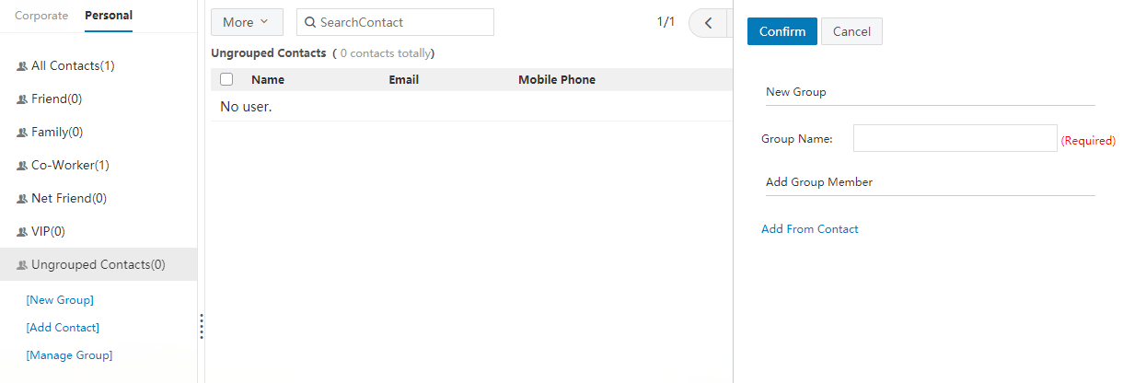

More operations of contact group:

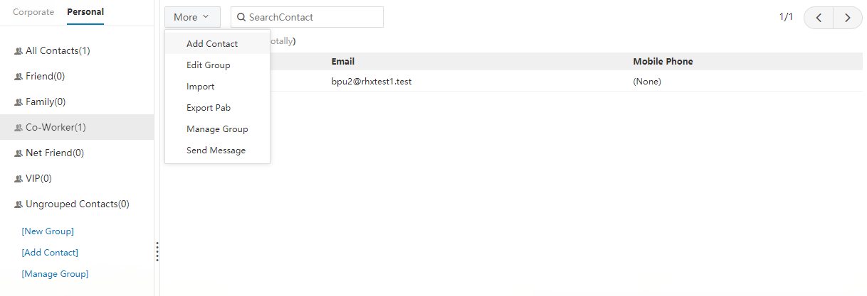

- New Contact

Click "New Contact" in the drop-down list of "More" to create a contact.

- Edit Current Group

Click "Edit Current Group" in the drop-down list of "More" to edit the currently selected contact group, including editing the group name, add/remove group members. Note that the contact group names cannot be re-edited for groups that exist on the system.

- Import Contacts to Group

Click "Import" to import contacts to the designated group via CSV or VCF files.

- Export Personal Contacts

Click "Export Personal Contacts" to select to export the personal contacts in CSV or cCard format.

- Contacts Management

Click "Contacts Management" to uniformly manage all groups in personal contacts, such as clear the group or delete the group.

- Send Mail to Group

To send mail to the entire group, you can click the "Send Mail to Group" button to directly enter the "Compose" page, and the system will automatically add the E-mail address to the recipient's address field.

Search Contact

If the user finds that more and more address items have accumulated in the contacts and are difficult to find or organize, the user can use the "Search Contact" function to search and locate the required address. Click the search icon 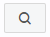 on the page to enter the "Search Contact" page.

For organizational contacts, the system also provides advanced search, which can search according to the name, E-mail address, mobile phone and company phone number in the contacts, and specify whether to search by groups. The searched results will be displayed in a list.

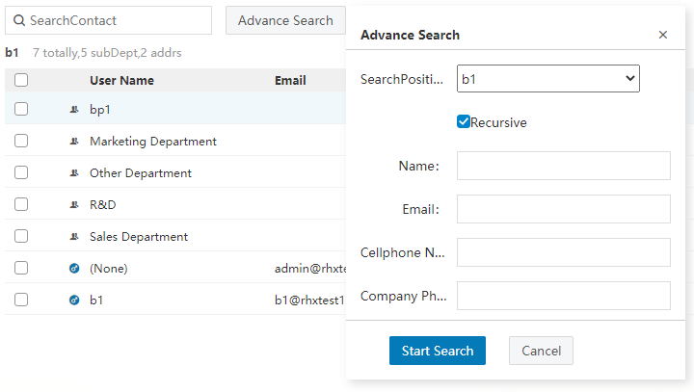

Settings

You can click the  button at the lower right corner mailbox the mail page to enter the setting center, or click the "Personal Settings" button on the avatar in the upper left corner of the mailbox page to enter the setting center.

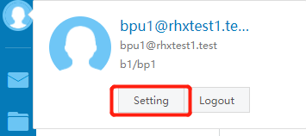

The setting center page is as shown in the figure below.

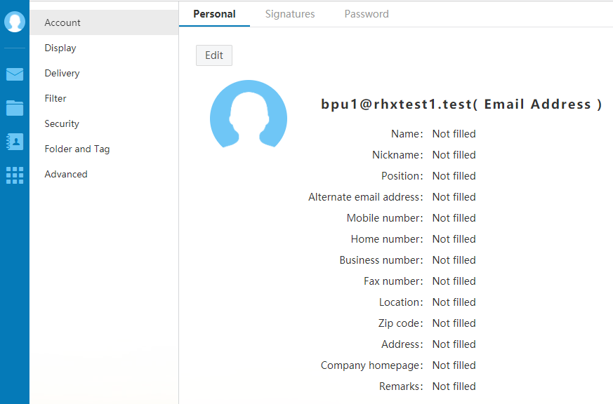

Personal Information

Personal Information

You can click "Personal Information" and the "Personal Information" page will be displayed; and you can click "Edit" to modify the user attributes. After completing modification, click "Save Modification" and the modification will take effect. When you send an E-mail, your name will appear in the "From" field of the sending mail.

Mailbox Password
You can click "Mailbox Password" to enter the password modification page and modify the mailbox password. When you log in next time, you need to input the new password.

Modify Password: After verifying the original password, you need to enter the new password and confirm it, and click "Save" to modify the password.

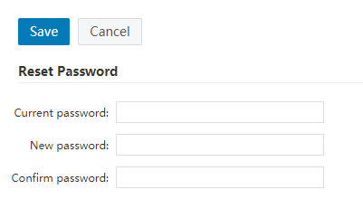

Client Password: The client-specific password is the exclusive password used to log in to third-party mail clients (such as Outlook, Foxmail, Mail App, etc.). You can click the "+" icon to add a new specific password.

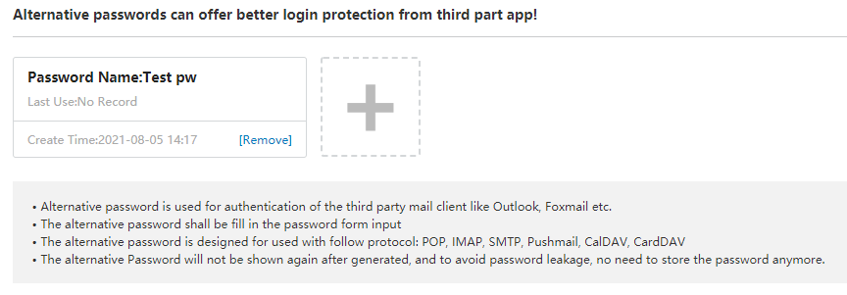

Signature Settings

In "Compose" page, if you select "Insert Signature", the signature contact will be displayed at the bottom of the mail body. In "Signature Settings" page, you can set up to 15 signatures, and set the position to add the signature (bottom of the mail/after mail body but before reference text).

Click "New Signature" to enter the signature name and content (optional rich text editing instructions), and click "OK" at the top left to save the signature.

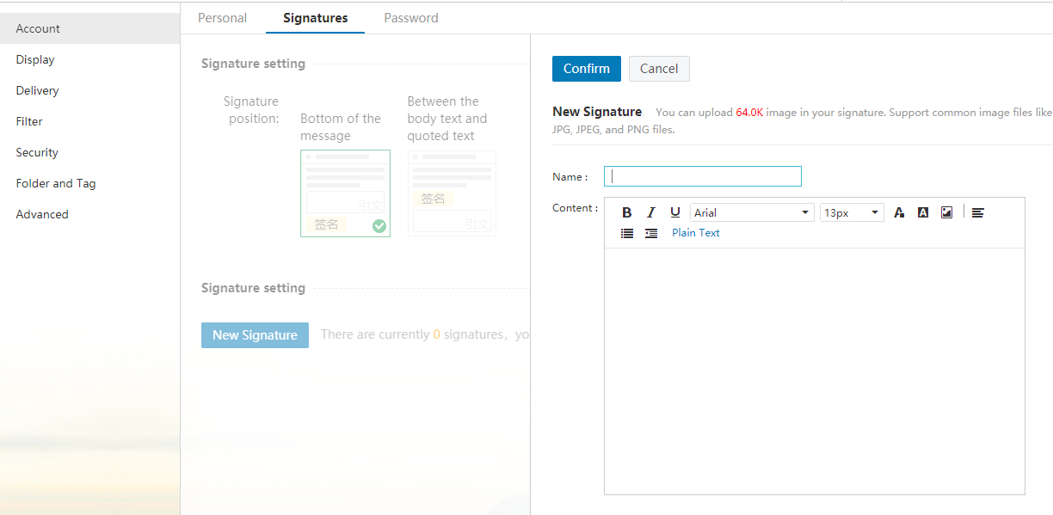

For the new signature, you can click the icon of the signature to set the signature as default, and click "Delete" or "Modify" button at the top right to delete or modify the signature.

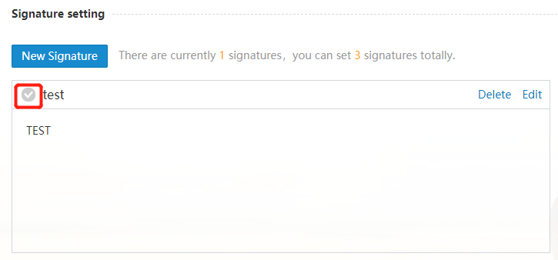

Interface Display Settings

Mailbox Display

The "Mailbox Display" page provides multiple setting parameters, including Display Page After Login, System Style, Language (Simplified Chinese, Traditional Chinese/English/Japanese) and Time Zone; after modification, click "Save" to complete the modification.

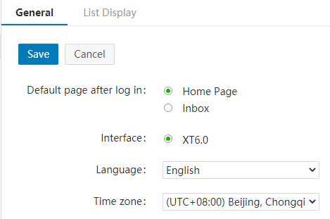

Mailbox List Display

The "Mailbox List Display" page includes multiple mailbox list setting items, including Show Mails Per Page, Reading Pane, Conversation Mode, Snippets, Mail Size, Font and Size, Time Display, and Default Sort of Full-text Search Results.

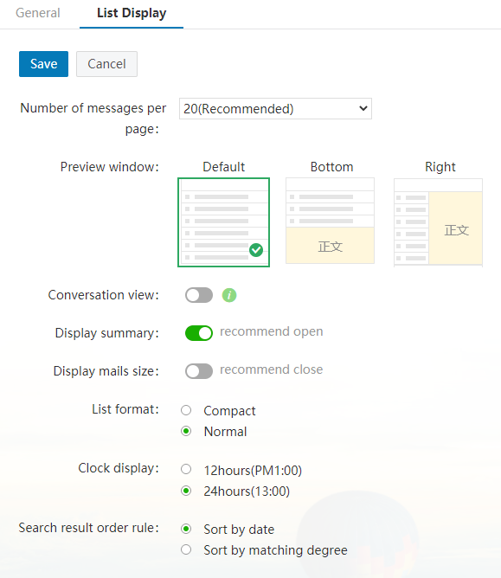

Sending and Receiving Settings

You can click "Sending and Receiving Settings" to enter the setting page, which includes Composing Settings, Replying Settings, Reading Settings, Auto-forward, Vacation Responder, and Template Settings.

Composing Settings
The "Composing Settings" provides setting parameters including default sending account, default editing mode (multimedia method/plain text method) and relevant composing settings.

Replying Settings

The "Replying Settings" can set whether to include the original mail when replying to the mail, the form of the reply subject prefix and handling of original recipients in case of reply all.

Reading Settings

The "Reading Settings" can set multiple reading parameters, including whether to open in a new window when reading, jump page after deleting the mail, operations when receiving a "Return Receipt" request, and whether to expand the "Reply/Forward" prefix in the subject.

Auto-forward
After enabling "Auto-forward", you can set to enable auto-forward and save the mail to the mailbox in any cases, or set to forward when the mailbox capacity is saturated. After enabling "Auto-forward", you need to add the specified forwarding address.

Vacation Responder
After enabling "Vacation Responder", you can set the time period and message content of vacation responder. In addition, you can also set only reply to users of the organization and remind my auto-reply settings on homepage.

Template Settings
Using template mails when composing can improve the sending efficiency.

You can click "Template Settings" to enter the "Template Settings" page; click the "+" icon to create a template mail; after filling in the template mail name and content, you can click "Save" to complete the creation of template mail. You can also import a file to create a new template mail. After creating the template mail, you can directly use the template when composing.

Category

Categorize

When a mail arrives, the system will automatically categorize or block the mail according to the categorization conditions you set. Coremail supports various categorization rules, and you can store mails of different objects, subjects and sizes in different folders. In addition to categorize the incoming mails, Coremail can also sort the historical mails that conform to the categorization rules, and the user can select whether to apply the rules to historical mails. You can set according to the path as shown in the figure below.

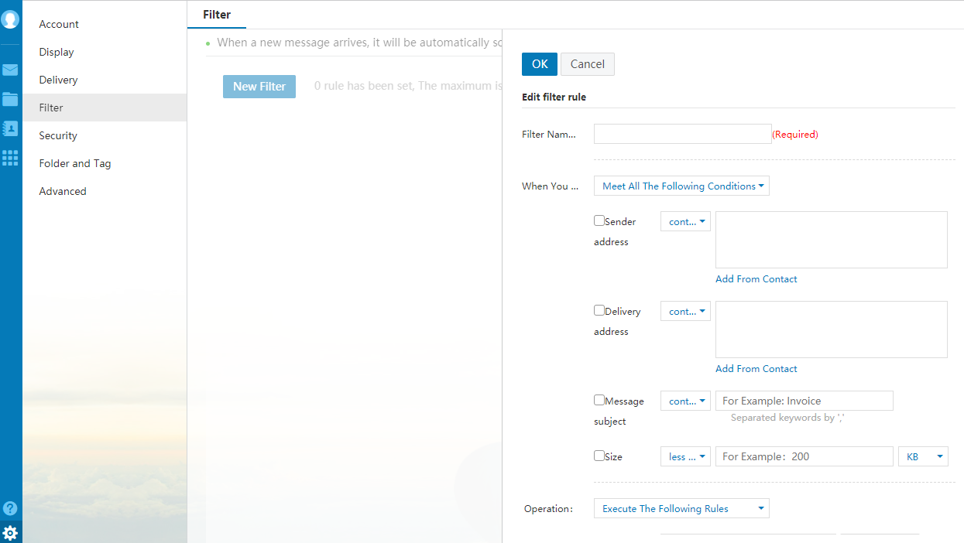

Important Mail Settings
According to statistics, professionals process more than 10,000 mails a year, and each mail takes an average of two minutes, or more than 13 days in total. Among them, 20 percent of the time -- 66 hours -- is spent on sorting important mails. Identifying and prioritizing important mails quickly become the keys to time management and productivity.

Through in-depth research on electronic office behavior, Coremail has pioneered the important mail function, and automatically retrieve new mails to realize the purpose of quick access to important mails. Coremail doesn't just provide a function, but it provides an efficient way to process your mails and helps you be more productive.

Customize important mails for precise positioning

The user can customize important contacts and add important subject. When an incoming mail meet the conditions of important mails, the system will automatically mark the qualified mail as important.

Quickly add/cancel bringing flexibility

The user can also manually set or click the yellow star to quickly mark the mail as important. Mails marked as important will have a yellow star to make them more visible and easier to be checked.

Automatically link important contacts

Important contacts customized by the user in important mail filtering rules will be automatically added to the "Important Contacts" group in personal contacts; and the user adding or deleting contacts in "Important Contacts" group in personal contacts will also be automatically linked to important mail filtering rules.
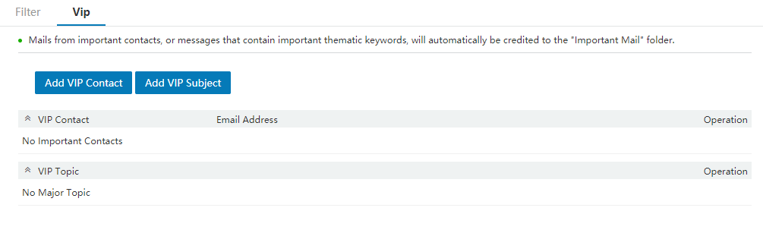

Security Settings

Whitelist

After adding an E-mail address to the whitelist, mails from that address will not be affected by the anti-spam rules, and future mails from that address will not be filtered.

Click "Security Settings - Whitelist" to enter the whitelist setting page; click "Add"; input the whitelisted E-mail address in the right text box; click "OK", and the system will add the address to the whitelist on the right side. To add multiple whitelisted addressed, you just need to repeat the above operations.

Blacklist

After adding an E-mail address to the blacklist, all mails from the address will be blocked.

Click "Security Settings - Blacklist" to enter the blacklist setting page; click "Add"; input the blacklisted E-mail address in the right text box; click "OK", and the system will add the address to the blacklist on the right side. To add multiple blacklisted addressed, you just need to repeat the above operations.

Anti-virus

The Coremail system provides anti-virus dual engine support. You can set up anti-virus protection to protect you from the attack of virus mail. In "Security Settings - Anti-Virus", you can make the following settings:

Handling of mail: Anti-virus; not check

Handling of virus mail: Set different countermeasures for successful anti-virus, unsuccessful anti-virus and uncertain cases of virus, such as add mark, store in [Virus] folder or discard, etc.

Whether to notify user: Whether to send a notification of the virus to the user.

Whether to notify sender: Remind the sender that the outgoing mail contains virus and may cause the recipient to fail to receive the mail.

Anti-spam Level
Click "Security Settings - Anti-spam Level" to enter the setting page. In this page, the user can choose three different levels of spam determination methods, including:

Close: The system does not intelligently categorize the mails and directly deliver the mails to inbox, or categorize or block the mails according to categorize settings.

Normal: The system analyzes based on past experience and intelligently process the suspicious spam.

Strict: The system uses strict filtering method to operate the suspicious spam according to your settings.

Security Lock Settings
You can add a security lock to the important information in the mailbox to ensure the security. After setting the security lock, you need to input the security lock password for verification when you log in to enter the selected range next time.

Click "Security Settings - Security Lock Settings" to enter the "Security Lock Settings" page; turn on the security lock, and a floating "Security Window Settings" window will be displayed on the right side; select the operations need to be protected and the protection range of security lock; and click "OK" at the top right.

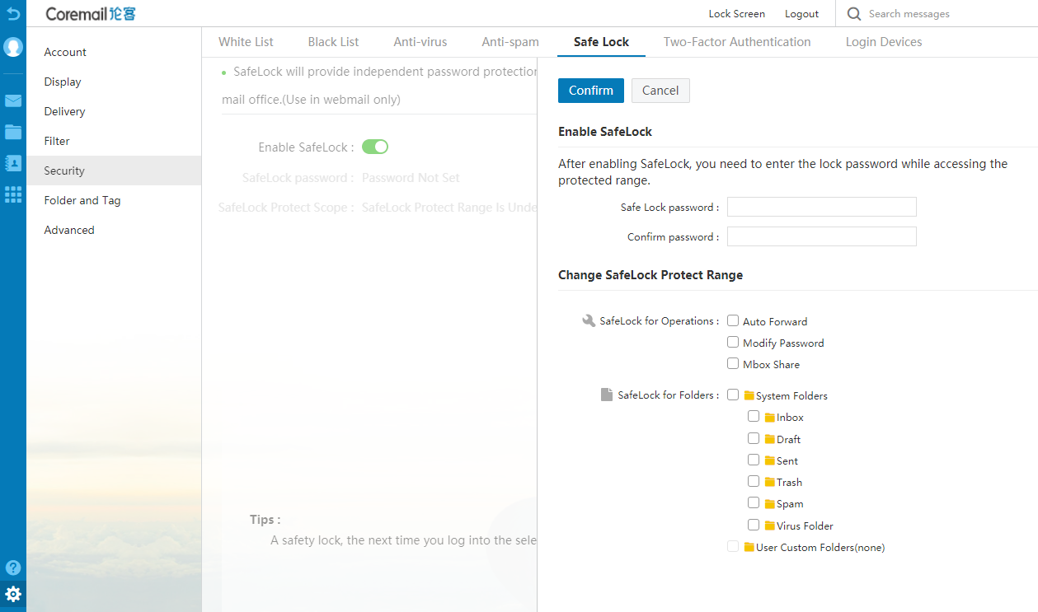

Anti-spam Notification
After the admin sets to enable spam notification in Webadmin, the user can set the notification frequency of spam notifications in "Security Settings - Anti-spam Notification" of Webmail, and check the spam blocking condition regularly. (Note: Spam contains the statistics of quarantined mails).

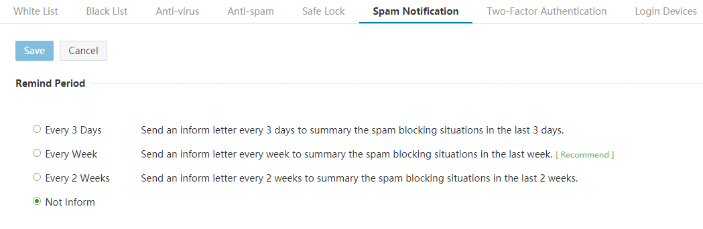

Secondary Verification Settings

The secondary verification realizes the double protection of login, which can better protect the mailbox security. If the admin enables user customization in the password policy, the user can customize the secondary verification method in Webmail, including APP authorization and SMS code.

Login Device Inquiry
Trusted Device: Display the devices that are trusted and do not require secondary verification when logging in again. The user can cancel the trusted device, which will require secondary verification when logging in next time.

Latest Login Device: Record the devices logged in in the last 30 days

Folders and Labels
The "Folders and Labels" includes "Folder Management" and "Label Management" modules.

Folder Management
Click "Folders and Labels - Folder Management" to enter the "Folder Management" page. In this page, you can create a new folder, view folder details, sort folders and delete/rename non-system folder, and view the current number of mails and mailbox space usage.

The mailbox navigation bar provides the mailbox folders frequently used by the user. You can also enter the "Folder Management" interface through the settings icon behind "Other Folders".

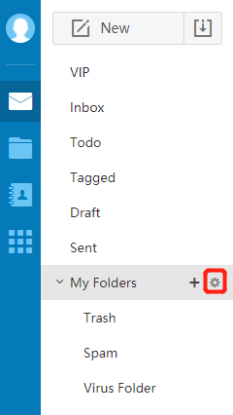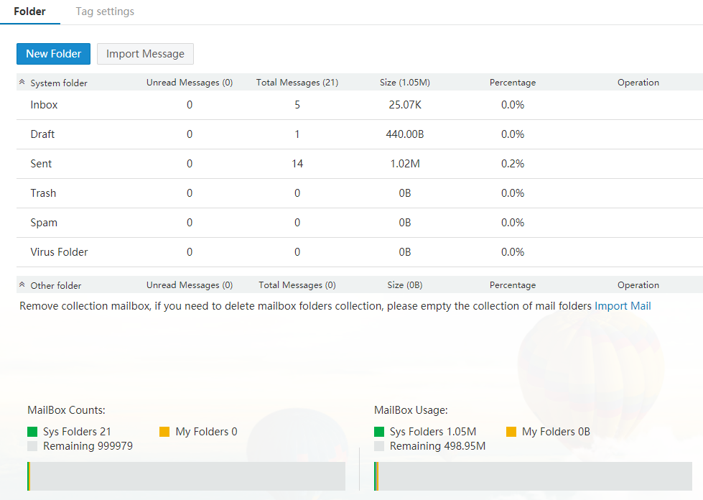

The "Folder Management" page displays the mailbox capacity status. If your mailbox capacity is almost full, the system will pop up a prompt indicating that the space is insufficient, and you can choose to clear the mails in some folders. The page also provides the number of unread mails, number of total mails, and space ratio and other information of system folders, other folders and other mailboxes.

New Folder

Click the "New Folder" button of "Folder Management". The Coremail system supports multi-level nesting of folders, and you can continue to create custom folders within folders. When creating a new folder, you must specify the folder's location. You can fill in the new folder name, select the location from the drop-down list, and click "OK" to create a new folder in this location.

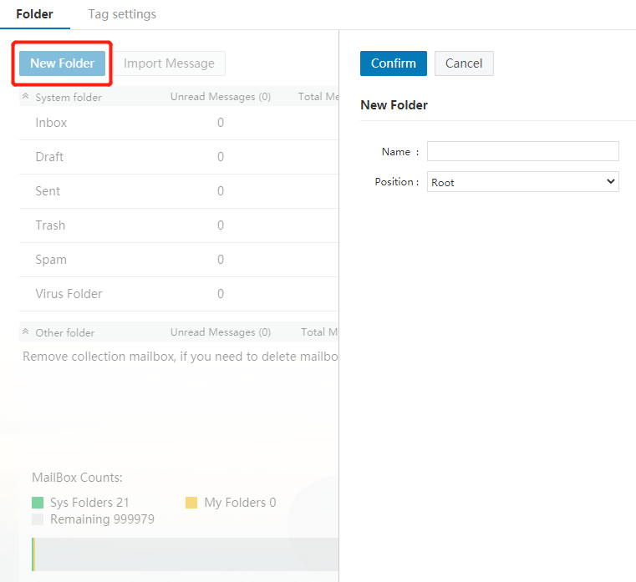
The folder name can be numbers, characters and Chinese characters, and supports long folder names, but it cannot be the same as the system folder name. If it is the same as the system folder, the system will prompt "You cannot create a new system folder".

You can also create the icon behind the mailbox navigation bar to jump to the new page to create a new folder.
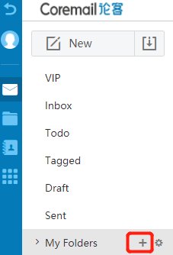

Delete Folder
The user can only delete or rename the customized folders, and cannot delete or rename the system folders, such as Inbox, Drafts, Sent, and Trash.

Click the "Delete" button behind the customized folder to delete the folder. Non-empty folders cannot be deleted directly. You need to empty the mails in the folder or transfer the mails before deleting the folder.

[Note] Clearing mails in [Trash] folder cannot be recovered, and clearing mails in other folders will be transferred to the [Trash] folder.
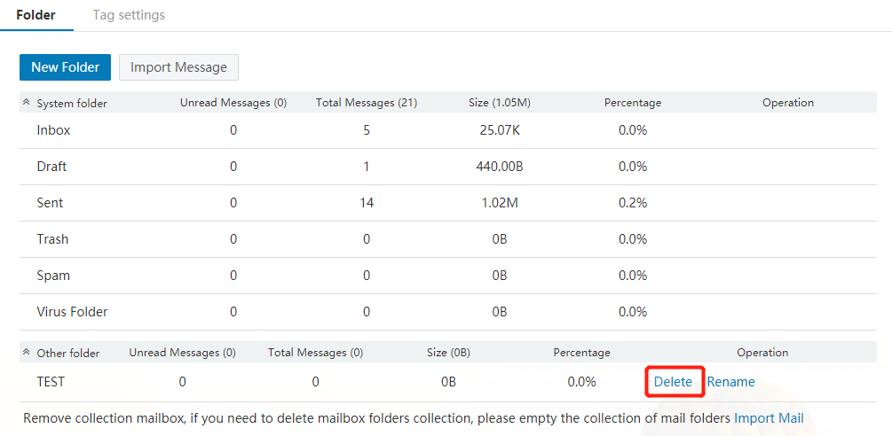

Label Management
Click "Folders and Labels - Label Management" to enter the "Label Management" page. The "Label Management" uniformly displays all labels. The system has 9 labels by default.

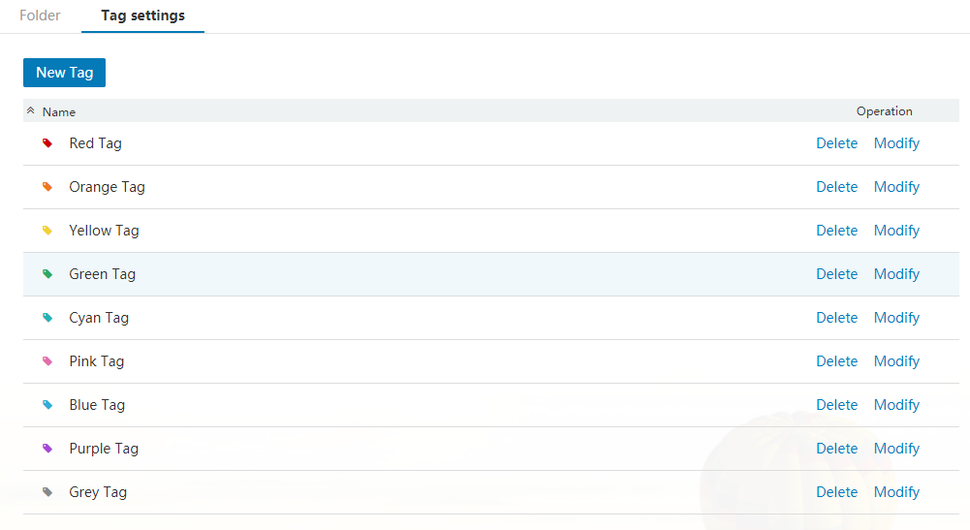

The user can click "New Label" to create a new label.

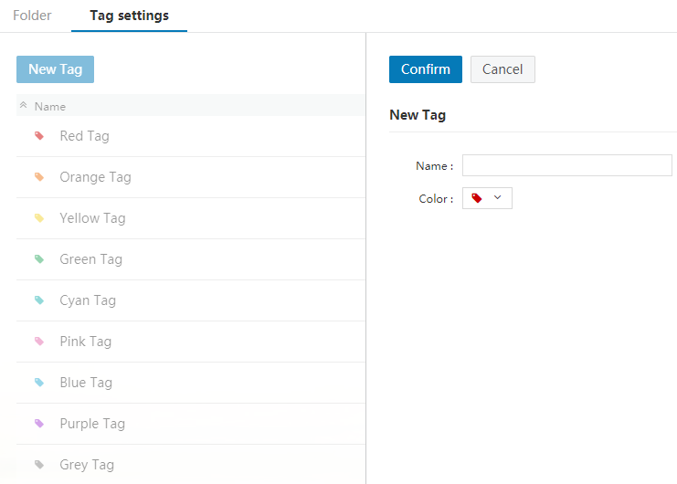

The user can also click the "Delete" and "Modify" button behind each label to delete or modify the corresponding label.

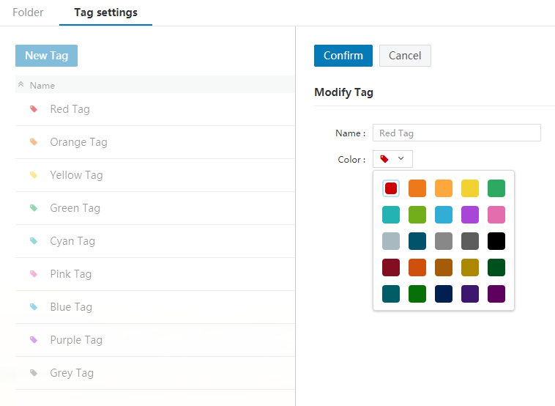

Schedule Settings
Schedule management include the following content: Schedule display settings, new schedule and schedule settings and sharing.

For details, please refer to "Coremail XT V6.0 Meeting and Schedule Manual".

Advanced
In the user interface, you can set the share mailbox, collect from mailbox, POP3, Coremail Push, reminder and other advanced features to facilitate office work.

Share Mailbox

In collaboration, you may need to share one's mailbox with another person, authorize them to view mails, or send mails on your behalf. From the perspective of enterprise application and security, Coremail provides mailbox sharing function closer to enterprise management mode.

The user can go to "Settings - Advanced" and click "Share Mailbox" to enter the share mailbox interface. In this interface, the user can view the mailbox users shared to it, or share its mailbox to other users and set the permission.

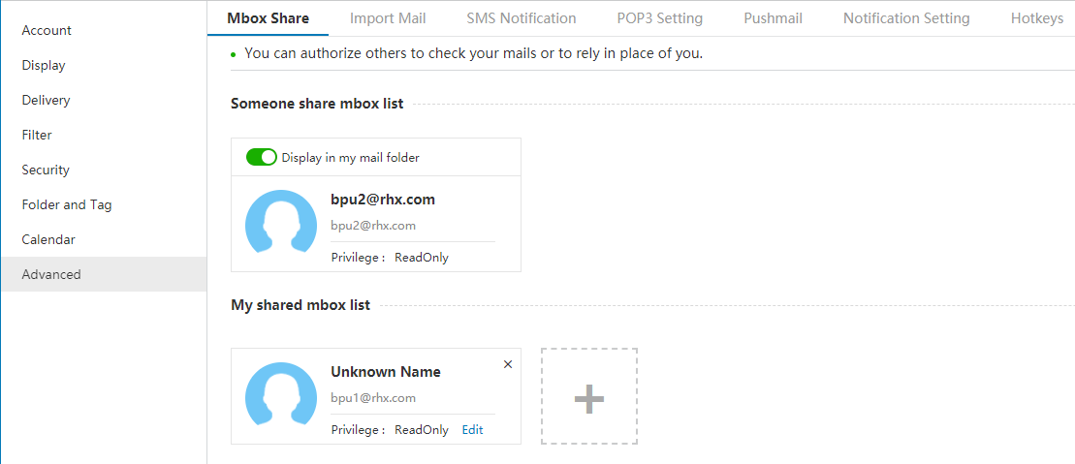

Secure sharing and no login required

Different from the concept of "public mailbox" where more than one person logs in to one mailbox, you can authorize others to view and edit your mails, and the authorized person can view your mails in his or her own mailbox without knowing your account password or logging in your mailbox. You can also easily view or cancel the sharing authorization.

Strict control and clear division of permissions

Coremail strictly restricts the permissions and provides three permissions of "read-only", "send on behalf" and "send as", and have different controls on the reading of mails, reading status and operation of sending mails.

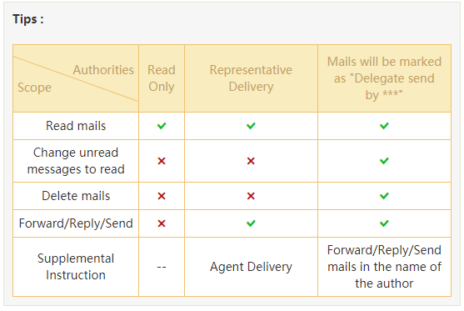

Collect From Settings

You may have more than one mailbox, and you may need to log in to different mailboxes to receive your mails. The "Collect From" function allows you to receive mails from other mailboxes easily through only one mailbox, saving the time of collecting emails from one website to another.

Click "Settings - Advanced - Collect From Settings" to open the collection mailbox account management page. As shown in the figure, you can view the current collection mailbox account information and collection status.

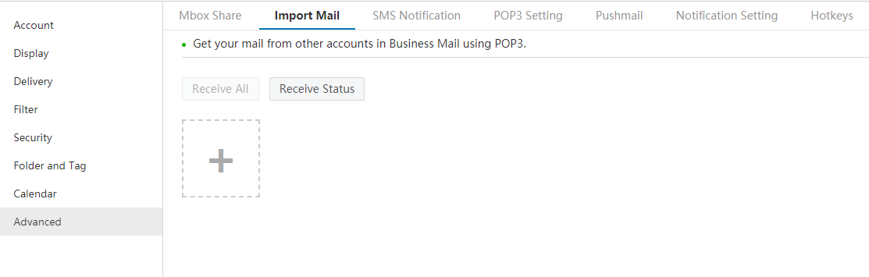

(1) New collection mailbox

Click  icon to enter the new collection mailbox account interface, as shown in the following figure.

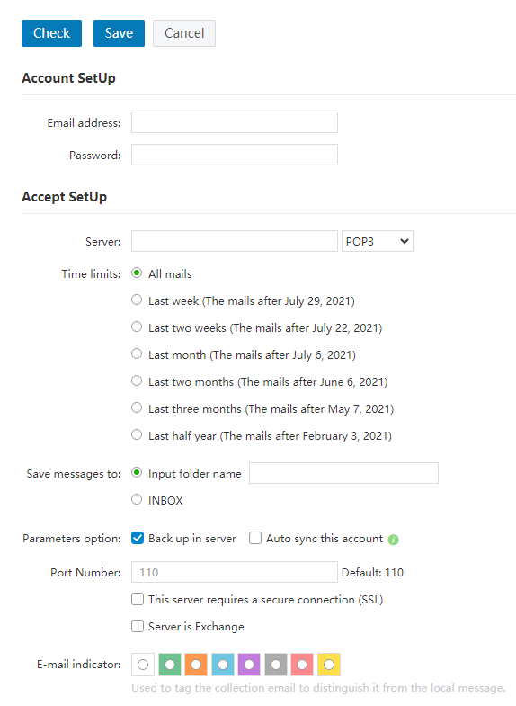
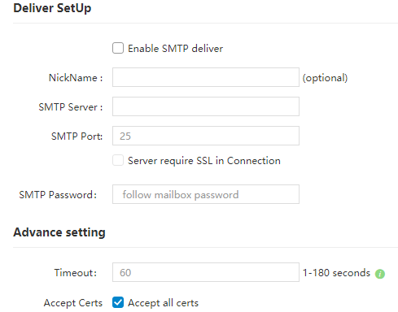

Account Settings

E-mail Address: E-mail address to receive mails, such as audit@test.com.

Mailbox Password: Login password of mailbox to receive mails.

Receiving Settings

Receiving Server: IMAP/POP3 server name of mailbox to receive mails, such as pop.test.com.

Time Range: Set a time range for the mails to be received.

Receiving Folder: Specify the storage location of the received mails.

Parameter Options:

(1) Keep mail backup when receiving. If this option is selected, after using Coremail to receive mails, the POP server will keep these mails; if it is not selected, Coremail will delete these mails from POP server after receiving them.

(2) If "Automatically receive this account" is selected, the system will automatically receive mails for this account on POP server.

Port No.: Default to 110. When adding collection mailbox account, it supports SSL connection settings to strengthen the security protection of the sending and receiving mode. When SSL security protection is selected, the port number will be automatically changed from 110 to 995.

Different Color: The user can choose different colors to mark the mails of the mailbox to distinguish them from local mails.

Sending Settings

Enable SMTP sender for sending: If this option is selected, it is equivalent to sending mails through an SMTP server rather than through Webmail.

Sender Alias: The name of the sender seen by the recipient after receiving the mail. This option can be left blank.

Sending Server: If "Enable SMTP sender for sending" is selected, this field must fill in the name of SMTP server.

Sending Port No.: The standard SMTP server port number is 25. If "The server requires SSL", the port number should be set to 994.

SMTP Password: Fill in the mailbox password.

Advanced Settings

Server Timeout Seconds: The default range is 0-180s. If the user sets to 50s, and the user's computer fails to connect to the server within 50s, it will be deemed as timeout, and a prompt message will be given. If the user cannot connect to the mail server of the recipient normally, setting "Timeout" can prevent the mail system from wasting resources to connect to the recipient's mail server.

After setting the collection E-mail account, you can click "Add" to add the account. To add multiple accounts, you just need to repeat the above operations. The user can set up to 5 collection and sending E-mail accounts. After adding, the system will automatically update these accounts to the navigation bar on the left side of the mailbox. The user can expand "Other Folders" and click the account address to directly enter the mail list page of the account. The user can also click the icon next to the account address to manually receive the mails of the mailbox.

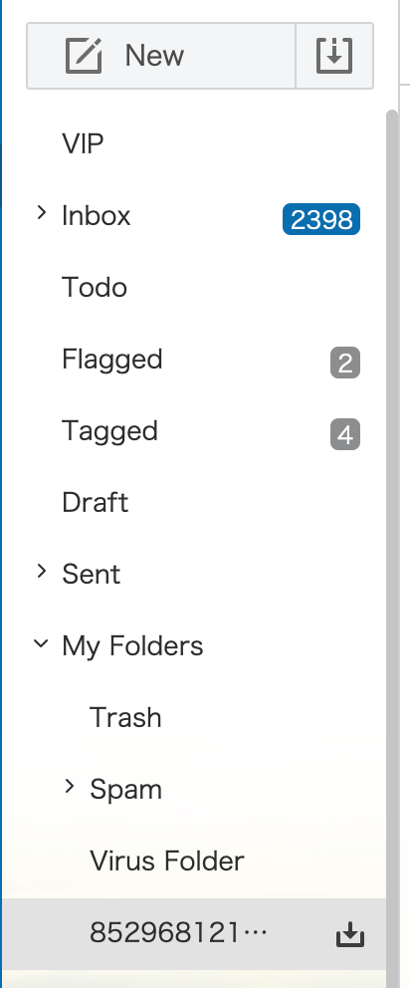

(2) Edit collection mailbox

Click the "Modify" button behind the corresponding collection mailbox address, and the system will load details of the collection E-mail account. After modifying the account, click "Save" to complete modification.

(3) Delete collection mailbox

Click the "Delete" button behind the corresponding collection mailbox address to delete the current collection E-mail account. After deleting the account, the mails previously received from the account will be kept in the mail system, and the user can check these mails in the set receiving folder.

POP3 Settings
Generally, after adopting POP3 protocol to configure the mailbox in client software, the user can only receive mails in Webmail's [Inbox] folder. If the user wants to receive mails in other folders of Webmail in client software, it needs to set in "Advanced - POP3 Settings".

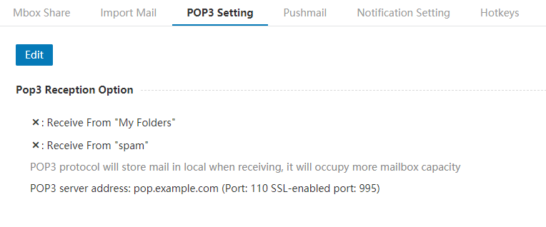

Receive "Other Folders": Set to receive mails in other folders with POP3

Receive "Spam": Set to receive spam with POP3

Coremail Push

Coremail Push is an application product dedicated to quick mail communication based on smartphones or tablets. Each mailbox can support 10 mobile terminals concurrently.

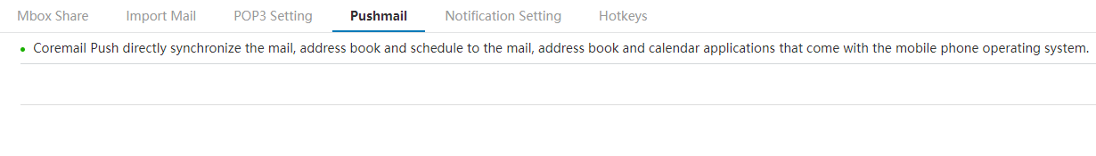

Reminder Settings
After the message reminder is enabled, the system will remind the user when a new mail arrives. The user can select the folders to enable message reminder.

After the APP push reminder is enabled, the user will receive a prompt in APP when the user logs in via Webmail.

Keyboard Shortcuts
After the keyboard shortcut function is enabled, the user can use the default keyboard settings to operate the mails.

Application Center

The "Application Center" includes two parts: System Applications and Other Applications. The "System Applications" part includes functions of "Self-service Inquiry", "Quarantined Mail" and "Skin Center". "Other Applications" part connects to external applications, such as OA system, so as to gather scattered information on a platform.

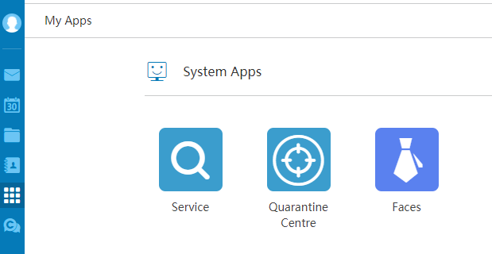

Self-service Inquiry
"Self-service Inquiry" can provide you with real-time inquiry of login, sending, receiving, deleting, and transfer station download records in the last 14 days.

You can click "Self-service Inquiry" in the "Mailbox Function Introduction" on the right side of the mailbox homepage.

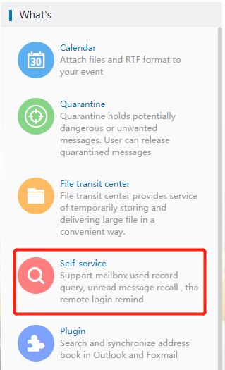

Or you can click the icon in the left navigation bar of the mailbox to enter the "Application Center" interface, and click 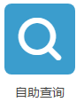 to enter self-inquiry.

Login Inquiry
The detailed login records include login time, IP address, login method and login results. By inquiring the login record, you can know whether your mailbox has been stolen. As shown in the following figure.

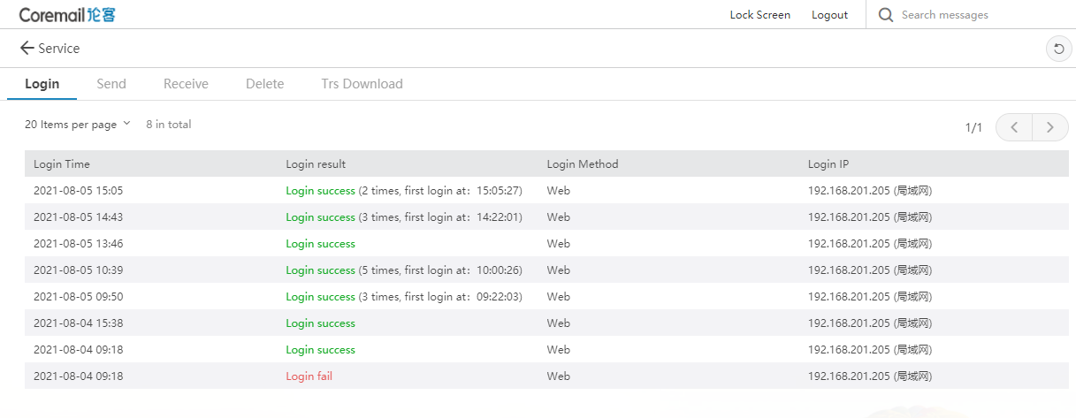

Sent Inquiry
With this function, you can not only inquire whether your mail has been received by the recipient, or whether the recipient has read the mail. At the same time, you can also quickly recall the sent mail through the "Sent Inquiry" interface.

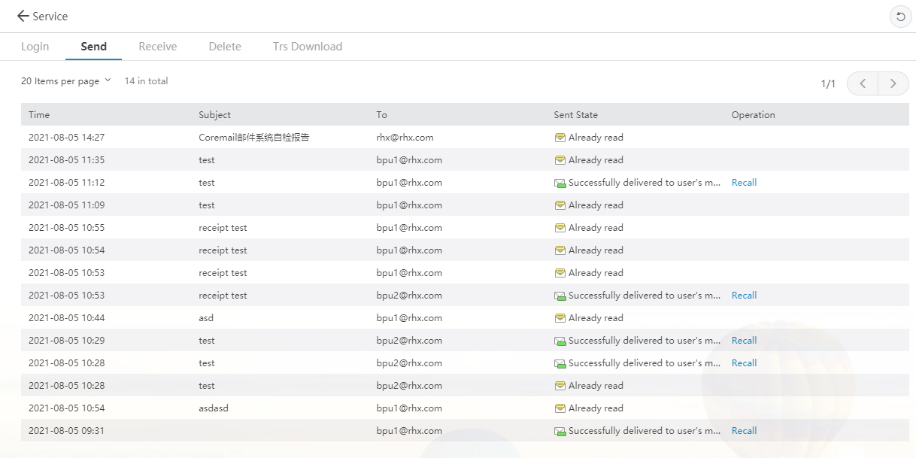

Receiving Inquiry
For the safety of your mailbox, suspicious spam or virus mails may be blocked. You can find the blocked mails through the receiving records, and check whether there is any lost mail through the "Receiving Inquiry". You can also inquire the folder where each mail is located.

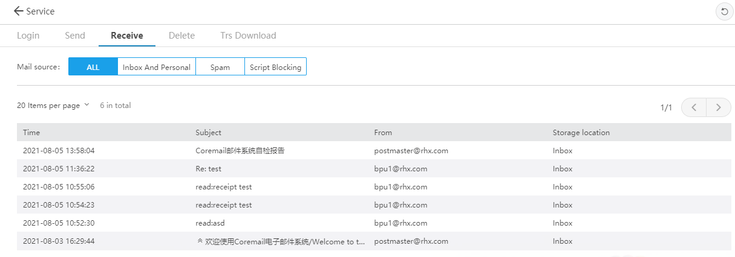

Deletion Inquiry
Regardless of whether a mail is deleted from the client or server, it can be inquired through the "Deletion Inquiry", including the deletion time, mail subject, sender and deleted information.

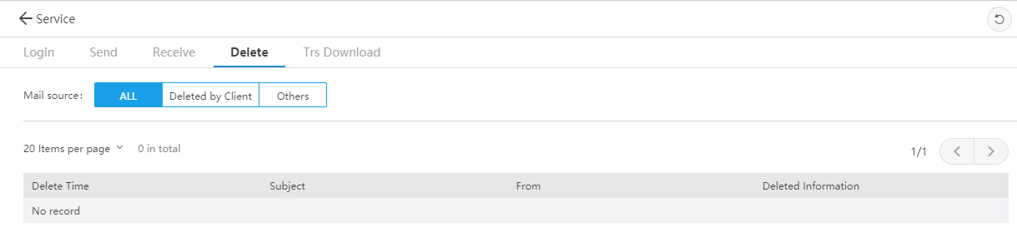

Transfer Station Download Inquiry
This function provides the downloading records of the transfer station files, including download time, IP, download person, file name, file size and other information.

Quarantined Mail
The user can enter the Webmail's "Quarantined Mail" management interface through the "Application Center - Quarantined Mai" path to operate the quarantined mails.

The user can go to "Quarantined Mail" to see suspicious mails that have been quarantined within the retention period. "Quarantined Mail" displays the receiving time, mail subject, sender and sender IP. The user can select whether to deliver the mail to inbox or delete it.
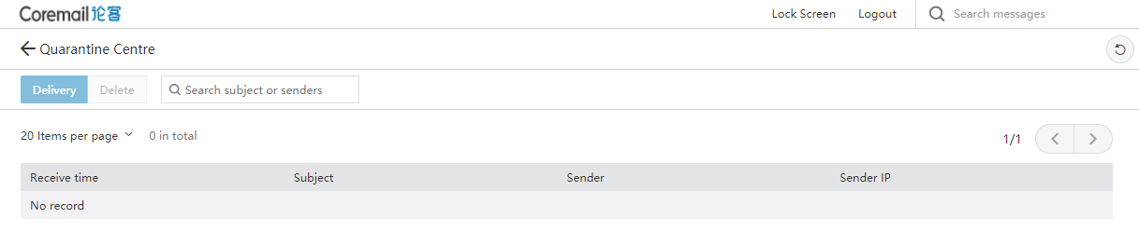

Help Center
The Coremail Mail System provides detailed online help information, and the user can obtain common problem solutions for a variety of functions from the "Help Center".

The user can click the icon above the login box to enter the "Help Center";

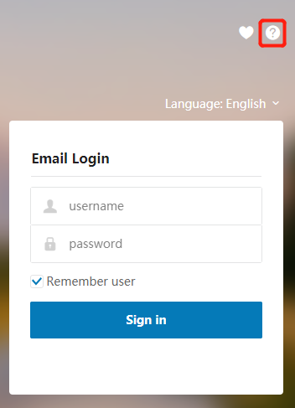

The user can also click the button in the lower left corner of the mailbox page after logging in to enter the "Help Center".

