Wopop Support Center

- Log into your wopop

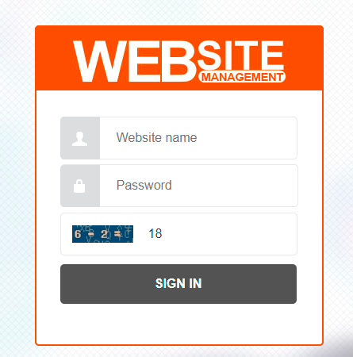

2、The Wopop Editor
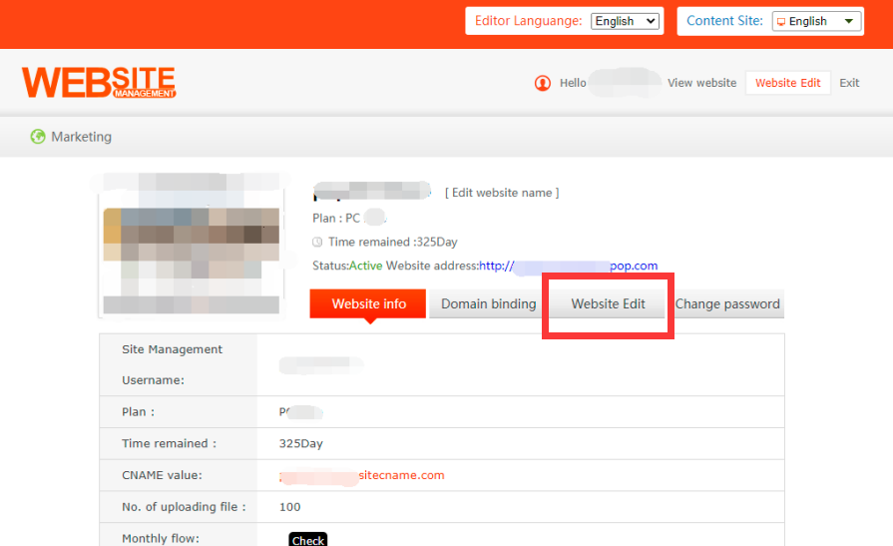

1. Module Editing Tools
Customize a module by clicking on it.
To edit a module:
- Click a module.
- From the Settings panel that shows, customize the module.

2. Moving, Resizing, Deleting, Rotating and Aligning a Module

Moving a Module
You can move any module on your site by dragging it to any position of your site.
Moving a module to previous layer or next layer
You can move a module to previous layer or next layer so that it appears on top of other modules or behind other modules on your site.
To move a module to previous layer or next layer:

- Click the module.
- Click the “Move to previous "or “Move to next” icons at the settings panel of the module to make it on top of or behind other crossed modules. You may also choose 'Move to Top' or 'Move to Bottom' your modules.

Resizing a Module
- Click the module to select it.
- Click and drag the stretch handles around the edges of the module.
- Repeat the same steps with the other stretch handles.

Deleting a Module
- Click the module to select it.
- Click the trash can icon or simply click 'Delete' on your keyboard.

Rotating a Module
You can rotate image modules, text modules, and other modules on the site.
To rotate a module:
- Click the module to select it.
- Click and hold the rotate icon from the top right of the module and drag it to fixed position.
- c.You can also change the angle from the module’s Settings panel-Properties.

Aligning Modules
There are a few ways to easily align and distribute the modules on your site.
To select and align multiple modules:
- Hold down the Ctrl key and click the modules that you'd like to align.
- Click Aligned button on the upper right corner then choose an alignment.
You can also choose to distribute the modules or match their sizes.

Locking a Module
To lock a module in fixed position at your page:
- Select a module.
- Click the lock icon that appears at the settings panel. click again for unlocking.

2. General Toolbar
Quick guidance to the icons of website toolbar:
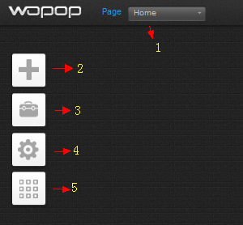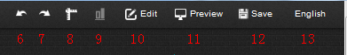
1-Page: add new pages & manage existing pages and backplanes. e.g.: rename page, copy or delete page, etc.
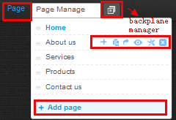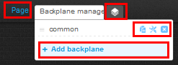
2-Add: add modules to your page, such as text, image, plug-in, navigation bar, html code, etc.
3-File: file management, e.g. upload files, categorize files, delete files, including image, text, music, etc.
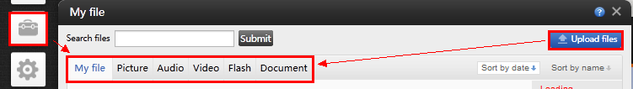
4-Setting: basic setting for your website, e.g.: site setting, page/site background, database backup, etc.
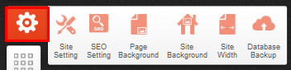
5-Templates: change your website template or initialize your website (note: both operations will delete all existing data and start fresh)
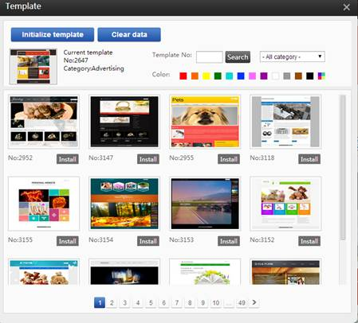
6-Undo: undo the operation of last step.
7-Redo: cancel the undo operation.
8-Gridlines: with vertical and horizontal gridlines, you can easily align your modules, these lines won’t be seen by your visitors.
9-Alignment: align multiple modules to make the page better-organized and neat.
10-Edit: copy, cut or paste what you selected. Ctrl+A: Select all; Ctrl+C: Copy; Ctrl+X: Cut; Ctrl+V: Paste.
11-Preview: See how your site will actually look and act in a live browser.
12-Save: save the current page layout and modifications.
13-Language: The language shown indicates the current edit content page. Click to choose here if you wish to edit pages in other content sites of a different language.

Click here to get more information :
https://www.wopop.com/PublicCenter/Help/Default.aspx

